Child Protection,

Reporting
  - Procedure

Approval Date 26 April 2022
Assessment Date 26 April 2025
Administrator AD Research Operations
AD Student Success and Wellbeing
AD Talent Acquisition, Organisaitonal Development and Workforce Diversity

Important Information

If you believe a Child is in immediate danger or in a life-threatening situation call 000 immediately.

If you have serious concerns that a Child has been harmed or is likely to be harmed you must notify Child Protection and Family Services as soon as practicable using the Child Protection Concern Referral Form available here —

http://www.dcp.wa.gov.au/ChildProtection/Pages/Ifyouareconcernedaboutachild.aspx

If you are concerned about the wellbeing of a Child please contact the Child Protection and Family Support Central Intake Team —
- 1800 273 889
- cpduty@cpfs.wa.gov.au

To report a concern out of business hours please contact the Child Protection and Family Support Crisis Care Unit —
- 9223 1111
- 1800 199 008 (country free call)

If you make a report or disclose relevant information to the Department, there are legislative protections for you. These are —

Protection of identity - with some exceptions, your identity must not be disclosed without your consent. For further information, refer to section 240 of the Children and Community Services Act 2004.

Legal protection – you are not subject to legal liability under State law providing the information is provided in good faith.

Professional protection – authorised disclosure of information cannot be held to constitute unprofessional conduct or a breach of professional ethics. As a result you cannot be disciplined by your professional body or incur any formal professional negative consequences at your workplace.

This Procedure has one process —

Process 1 — Child Protection Reporting Process.

Process 1 Child Protection Reporting

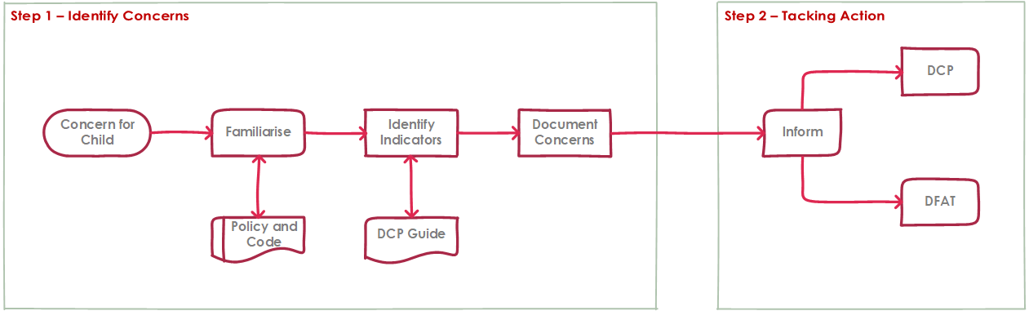

Identification of and Responses to Suspected Child Exploitation

Step 1 — Identify Concerns

Familiarise yourself with the Child Protection Policy and Child Protection Code of Conduct and the indicators of Child Exploitation as outlined in the following document: How do I recognise when a child is at risk of abuse or neglect?
- http://dcp.wa.gov.au/ChildProtection/Documents/HowDoIRecogniseWhenAChildIsAtRiskOfAbuseOrNeglect.pdf

Prioritise the possible impact on the Child over and above any concerns for Parents or other adults involved in the situation.

If you have observed indicators of abuse you will need to document your concerns as best you can.

Step 2 — Taking Action

If there are indications or Child Exploitation or a Child is currently at risk please inform your Supervisor or Manager and then work together, with your Business Unit to notify —

the Department for Child Protection and Family Support using the Child Protection Concern Referral Form —
- https://www.dcp.wa.gov.au/ChildProtection/Pages/Ifyouareconcernedaboutachild.aspx

the Department of Foreign Affairs and Trade —
- https://www.dfat.gov.au/international-relations/themes/child-protection/Pages/reporting-concerns-or-allegations-of-child-exploitation-or-abuse

End

