Public Interest Disclosure
  - Procedure

Approval Date 25 July 2022
Assessment Date 25 July 2025
Administrator Manager Integrity and Standards Unit

Important Information

The University is committed to the aims and objectives of the Public Interest Disclosure Act 2003 Act (WA). It recognises the value and importance of contributions of employees to enhance administrative and management practices and strongly supports Disclosures being made by any individual as to corrupt or other improper conduct.

PI Disclosers must be aware that once a Public Interest Disclosure (a PID) has been properly made, it cannot be withdrawn. The University may still continue to investigate the issues raised.

This Procedure has three processes —

Advising and Receiving a Public Interest Disclosure Process;

Investigating a PID Process; and

PID Lodgement and File Process.

Process 1 Receiving and Advising on a Public Interest Disclosure
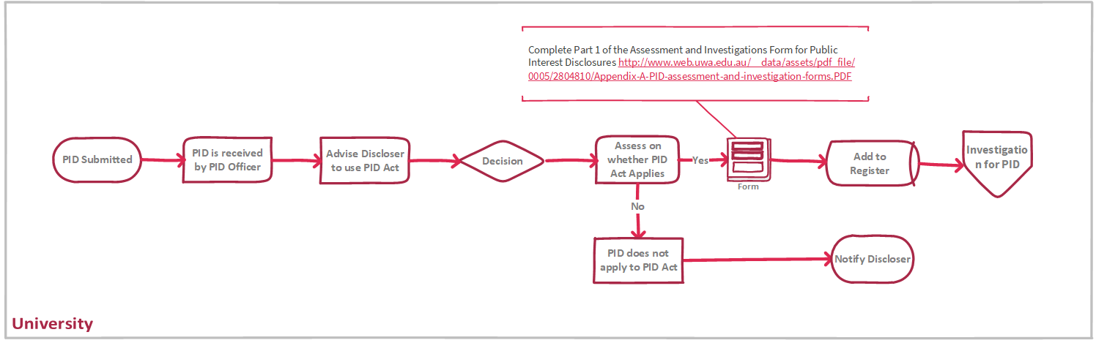

Reporting and Decision Making Procedure

Step 1 – Advising on Public Interest Disclosures

Where possible and practicable, an individual considering lodging a PID is encouraged to —

access information provided by the Public Sector Commission at —
- https://www.wa.gov.au/organisation/public-sector-commission/public-interest-disclosure-information-disclosers

contact one of the University’s Public Interest Disclosure Officers (a PID Officer) to discuss the matter(s) they are considering disclosing and to consider all options.

The University’s PID Officers are —
- Director, Human Resources,55 Broadway, Ground Floor, Crawley, Perth, Western Australia 6009
- +61 8 6488 3003 / +61 436 283 955
- fiona.keay@uwa.edu.au

- Director, Student Life | Gove1st Floor, Administration Building (South), 35 Stirling Highway, Perth WA 6009
- 61 8 6488 4370 / +61 408 901 889
- chris.massey@uwa.edu.au
- Manager,Integrity and Standards Unit
- G22, Hackett Hall , 35 Stirling Highway, Perth WA 6009+61 8) 6488 8547 / +61 457 704 628
- gina.barron@uwa.edu.au

Up-to-date contact information is available at —
- https://publicsector.wa.gov.au/document/pid-officer-contact-directory

Where possible, before an individual makes a PID to a PID Officer, the PID Officer must advise the individual of the following matters —

other options for reporting their concerns including making a complaint or lodging via the University’s external whistleblower service, STOPLine

that if they choose to make an appropriate PID —

they will not incur any civil or criminal liability for doing so;

they will not, for doing so, be liable —

to any disciplinary action under State law;

to be dismissed or have their services dispensed with or otherwise terminated; and

for any breach of a duty of secrecy or confidentiality or any other applicable restriction on disclosure.

that if they choose to make a PID, they may have the right to commence civil proceedings against anyone who subjects them to detrimental action as a result of making the PID;

that if they choose to make a PID, then their identity will not be disclosed except in accordance with section 16 of the Act;

that if they agree to disclose their identify they will need to fill out the Consent to Disclosure of Identifying Information Form —

https://www.web.uwa.edu.au/__data/assets/pdf_file/0008/2804867/Appendix-F-Consent-to-disclosure-identifying-information-form.PDF.

that if they choose to make a PID then they will have the right to be informed of the progress and outcome of the investigation and action taken as a result; and

that if they choose to make a PID, that —

they are only protected if, and only if, they believe on reasonable grounds that the information to be disclosed is true, or if they have no reasonable grounds on which to form a belief about the truth of the information but believes on reasonable grounds that the information may be true;

they will commit an offence, and lose the protection of the Act, if they know the information to be false or misleading in a material particular or are reckless about whether the information is false or misleading in a material particular;

they will forfeit the protection given by the Act if they disclose the information other than under the Act;

they will forfeit the protection given by the Act if they fail, without reasonable excuse, to assist a individual investigating the matter to which the information relates, by supplying any information requested; and

they may commit an offence if they disclose information that might identify or tend to identify anyone as a individual in respect of whom a PID has been made.

that the PID will first be assessed as outlined in Step 2.

based on the information provided, what steps the individual will need to take to make a PID.

Where the PID is received without a preliminary discussion and where it has not been made anonymously, the PID Officer should make contact with the PI Discloser and provide the information as above before taking any further action.

Step 3 - Assessing a Public Interest Disclosure

Following receipt of a PID, the PID Officer must make an initial assessment of whether —

the information disclosed relates to a public authority, a public officer or a public sector contractor of the University;

the information disclosed relates to the performance of a public function;

the information disclosed tends to show improper conduct;

the improper conduct is of the kind for which the PID Officer is the proper authority;

the Discloser believes on reasonable grounds that the information is true, or if they have no reasonable grounds on which to form a belief about the truth of the information but believes on reasonable grounds that the information may be true; and

the information is not protected by legal professional privilege, or of any other kind that should not be disclosed under the Act.

The PID Officer should complete Part 1 of the Assessment and Investigations Form for Public Interest Disclosures at —
- http://www.web.uwa.edu.au/__data/assets/pdf_file/0005/2804810/Appendix-A-PID-assessment-and-investigation-forms.PDF

If the questions in paragraph 3(A)(1) to (6) above are all answered ”yes”, then the disclosure is a PID to which the Act will apply.

The University might disclose information without the PI Discloser’s consent only when it is necessary to enable the matter to be investigated effectively and where reasonable steps have been made to inform that PI Discloser. However, before information is disclosed all reasonable steps shall be taken to inform any individual whose identity is to be disclosed. This information should be given, where practicable, in the Notification of Disclosure of Identifying Information Form —
- http://www.web.uwa.edu.au/__data/assets/pdf_file/0009/2804868/Appendix-G-Notification-of-disclosure-or-identifying-information-form.PDF

Investigating a PID
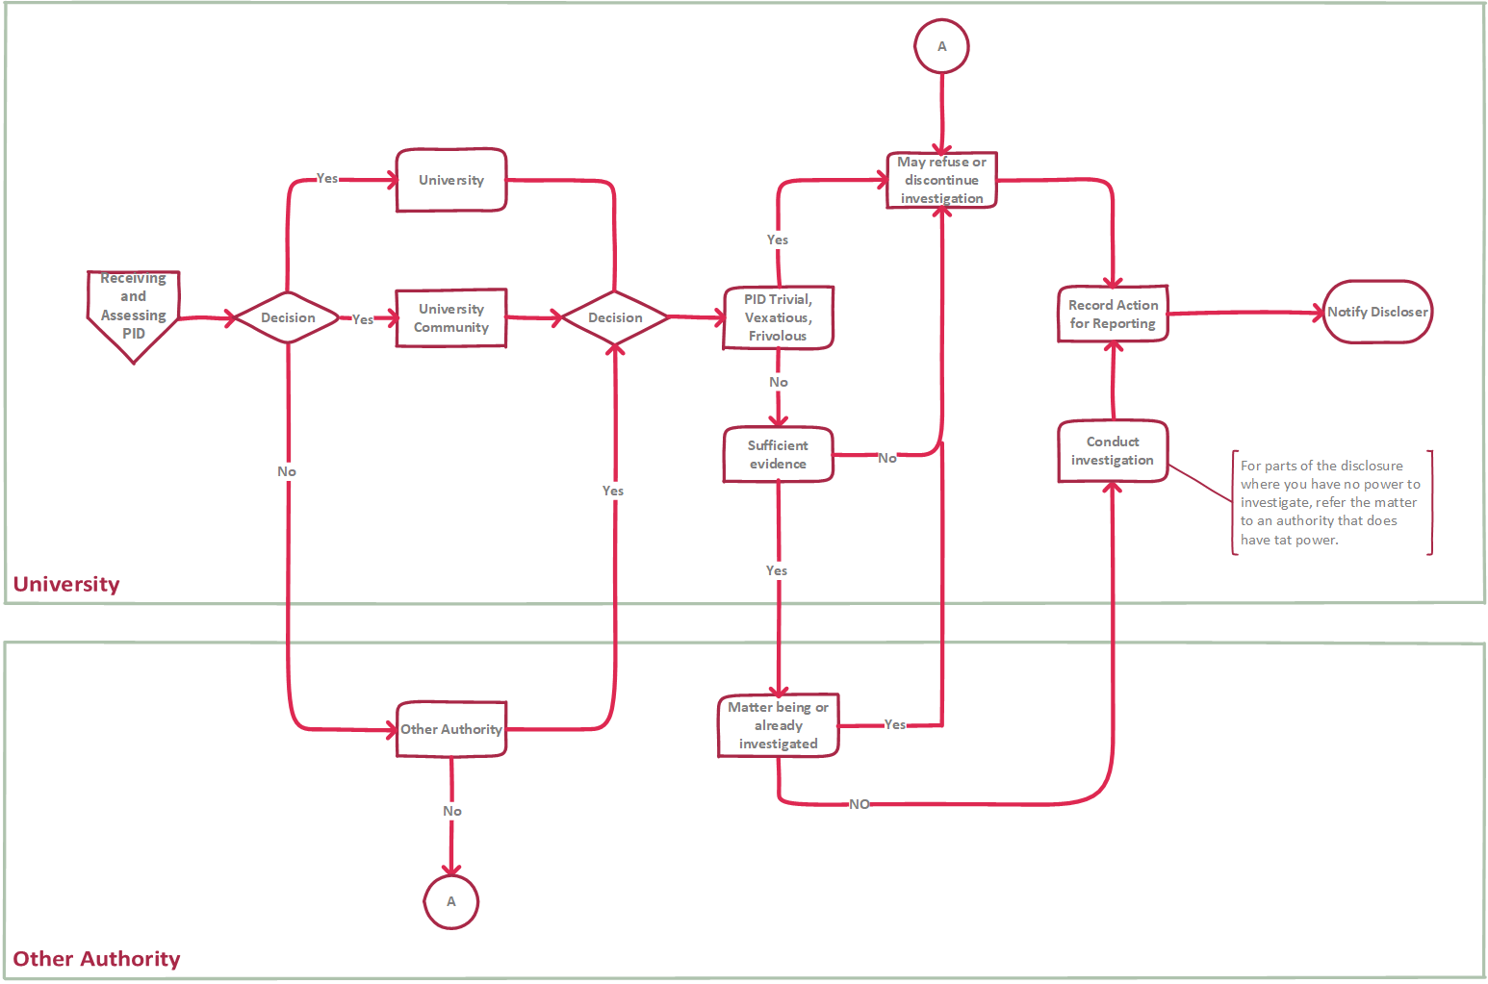

Investigating a PID Procedure

Step 1 - Investigating a Public Interest Disclosure

After receiving a PID, a PID Officer must consider —

whether the PID relates to the University, its officers, employees or contractors; or

the PID relates to a matter or individual that the University has a function or power to investigate.

If the answer to both of the questions in paragraph 4(A)(1) and (2) above is “no”, then a PID Officer is not required by the Act to investigate the matter.

A PID Officer must also consider whether —

the matter is trivial;

the PID is vexatious or frivolous;

there is no reasonable prospect of obtaining sufficient evidence due to the time that has elapsed since the occurrence of the matter; or

the matter is being, or has been, adequately or properly investigated by another proper authority to which an appropriate PID has been made under the Act.

PID Officer should complete Part 3 of the Assessment and Investigations Form for Public Interest Disclosures —

http://www.web.uwa.edu.au/__data/assets/pdf_file/0005/2804810/Appendix-A-PID-assessment-and-investigation-forms.PDF

If the answer to any of the five questions in Part 3 of the ‘Assessment and Investigations Form’ is “yes”, then a PID Officer is not required by the PID Act to investigate the matter.

Where a PID Officer considers that they lack sufficient power to effectively investigate a matter, but the information received causes him or her to form the opinion that a public authority, public officer, employee or public sector contractor may have engaged in improper conduct, then that PID Officer should refer the matter to another appropriate investigative body.

The PID Officer must discuss the PID with the Director Governance and General Counsel (unless the PID relates to that individual or position) so that consideration can be given to whether any external notification is required.

The PID Officer, without disclosing the identity of the PI Discloser or the PID Subject with the Director Governance and General Counsel as to how the disclosed matter(s) can be investigated.

Except where the PID Officer is also the Director Human Resources, the PID Officer will usually not have a role in the investigation other than to facilitate contact during the investigation other than —

to seek further relevant information sought by the investigator;

to seek permission to disclose their identity or to notify them that they may be identified (with the correct form); and

to provide them with updates on the investigation as appropriate.

Step 2 - Taking action following an investigation

A PID Officer must take action where they form the opinion that an individual may be, or has been, or may in the future be, involved in improper conduct. Action that may be taken includes —

preventing the matter to which the PID relates from continuing or occurring;

referring the matter to the Police or other appropriate body, or

taking disciplinary action against a individual responsible for the matter.

Before taking any action, the individual against whom the action is to be taken is to be given the opportunity to make written or oral submissions. Where disciplinary action is taken, the relevant University Policy must also be followed as well as any procedures required under an applicable enterprise agreement.

In taking any action, the PID Officer remains limited by the powers and functions that are conferred by the legislation under which they operate. The Act does not give PID Officers additional powers to take action.

As well as being limited to matters within the functions and powers of a PID Officer, the action to be taken is guided by what is necessary and reasonable in the circumstances.

Step 3 - Recording Action Taken

In addition to keeping other records, a PID Officer must —

complete Part 5 of the Assessment and Investigations Forms for Public Interest Disclosures —

http://www.web.uwa.edu.au/__data/assets/pdf_file/0005/2804810/Appendix-A-PID-assessment-and-investigation-forms.PDF

record a summary of the action taken in the Public Interest Disclosure Register —

https://www.web.uwa.edu.au/university/complaints/staff/pid

Step 4 – Notifying the Discloser

If it is decided not to investigate information disclosed under the Act, or the investigation is discontinued, then the PID Officer should be advised so that they can inform the PI Discloser and must provide them with a reason for this decision.

Within three months of the Disclosure being made, the PID Officer must notify the PI Discloser of the action taken or proposed to be taken in relation to the PID.

A PI Discloser may also request a progress report and where the investigation is not complete, the PID Officer may provide the PI Discloser with a report on the progress of the investigation, to the extent that it is reasonable, appropriate and permitted by law.

If an investigation is complete, then the PID Officer must provide a final report (in accordance withthe Act) to the PI Discloser, stating the outcome of the investigation and the reason for taking action following the investigation.

In providing information (section 11 of the Act) and reports to PI Disclosers, a PID Officer must not give information that, in their opinion, would be likely to adversely affect —

any individual’s safety;

the investigation of an offence or possible offence; or

necessary confidentiality as to the existence or identity of another individual who has made a PID under the Act.

PID Lodgement and File Process
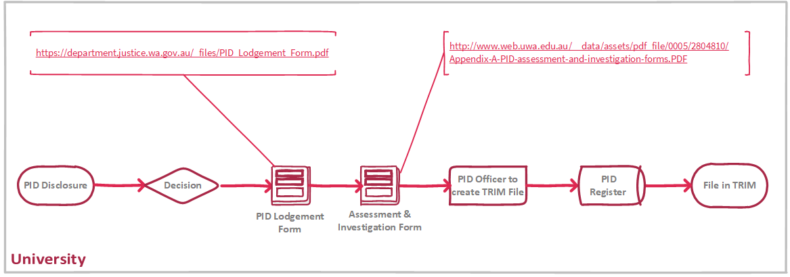

PID Lodgement Form and File Procedure

Step 1 – Lodgement of Form

If a Disclosure is a PID, the Discloser and a PID Officer can use the Public Interest Disclosure Lodgement Form located at —

https://www.justice.wa.gov.au/_files/PID-lodgement-form.docx

The PID Officer should also complete Part 2 of the Assessment and Investigation Forms for PID —

http://www.web.uwa.edu.au/__data/assets/pdf_file/0005/2804810/Appendix-A-PID-assessment-and-investigation-forms.PDF

Step 2 - Recording the outcome of an investigation

The outcome of an investigation should be clearly and comprehensively recorded. In addition to any investigation report, the investigating officer should complete Part 4 of the Assessment and Investigations Forms for PIDs —

http://www.web.uwa.edu.au/__data/assets/pdf_file/0005/2804810/Appendix-A-PID-assessment-and-investigation-forms.PDF

The result of the investigation should also be recorded in the Public Interest Disclosure Register —

https://www.web.uwa.edu.au/university/complaints/staff/pid

The University’s Principle PID Officer, the Manager of the Intergrity and Standards Unit, will keep these registers (electronic and hard copy) strictly confidential and in a secure place.

The Manager of Integrity and Standards Unit will make available extracts from the registers to the the Director of Governance and General Counsel for annual reporting to the Public Sector Commission.

Step 2 – Filing of Form

On completion of this form, a PID Officer should create a separate Records Management (TRIM) file for the PID, with the following text clearly marked on the front of the file.
- CONFIDENTIAL
- The material in this file relates to a Public Interest Disclosure made under the Public Interest Disclosure Act 2003 (WA).
- Disclosure of information that might identify or tend to identify either the Discloser or a individual in respect of whom the Disclosure has been made is an offence, unless the disclosure of that identifying information occurs in accordance with the Act.
- Penalty: $24 000 or imprisonment for two years.

The PID must also be recorded in the University’s Public Interest Disclosure Register by the PID Officer and maintained in a secure location. On completion, the Public Interest Disclosure Register must be provided to the University’s Principle PID Officer.

The Public Interest Disclosure Register template is available at —

https://www.web.uwa.edu.au/university/complaints/staff/pid

File documents in TRIM.

End

The five questions in Part 3 of the ‘’ referred to in paragraph 4(E) above are: (1). Does the disclosure relate to the proper authority, its officers or contractors? (2). Does the disclosure relate to a matter or person that the authority has a function or power to investigate? (3). Is the matter trivial? (4). Is the disclosure vexatious? (5) Is the disclosure frivolous?

