Uniview
  - The magazine of The University of Western Australia
Vol.47, SUMMER 2021
Making Waves

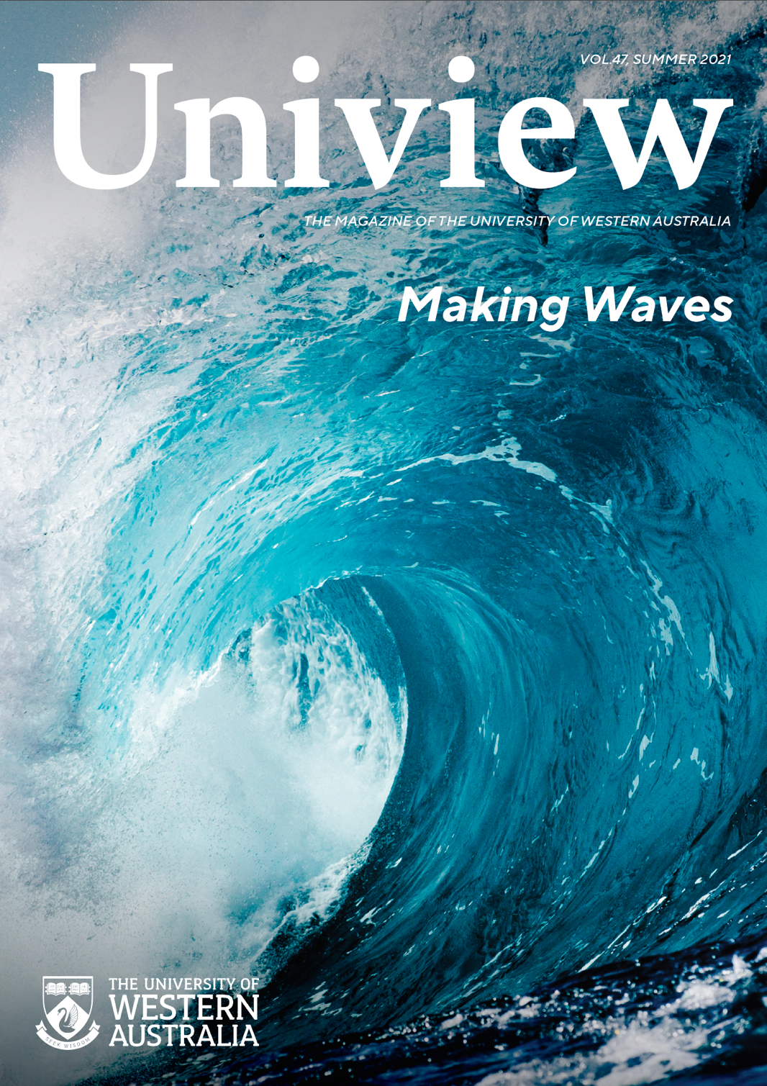

Message from the Editor
Welcome to our summer edition of Uniview.
With 2021 drawing to a close, we’d like to highlight some of the critical UWA research making a splash in areas of climate change, renewable energy, healthy environments and smart technologies.
The demands for adapting to a time of flux compel us to respond swiftly with smart solutions that address local, national and global challenges. As universities we are intrinsically part of a global response and we take pride in being at the forefront of robust innovation.
This edition showcases the strength of our marine energy research and offshore engineering with a focus on harnessing the power of the ocean to create renewable energy sources.
Our feature articles explore the impact of climate change on our lives, reveal sustainable ideas that mitigate such impact through ‘regenerative design’ in architecture and investments in public health emergencies, including the multidisciplinary work by epidemiologists to tackle global health inequities.
We are committed to creating a more clean, green and sustainable campus and becoming energy-neutral by 2025. As a smart university campus we aim to provide the perfect environment for learning and living, sharing of ideas, creation of knowledge and growth.
We hope you enjoy reading this edition over the summer break.
Alison Batcheler
Associate Director, Corporate Communications

Editor: Alison Batcheler
Uniview Coordinators: Milka Bukilic, Emily Glover
Editorial: Corporate Communications, The University of Western Australia, Perth, WA 6009
Telephone: +61 8 6488 4206
Design: UniPrint, The University of Western Australia
Printer: UniPrint, The University of Western Australia
Address changes: +61 8 6488 8000
Email: uniview@uwa.edu.au
Facebook: facebook.com/universitywa
Twitter: twitter.com/UWAnews
UWA Impact: uwa.edu.au/news
Material from Uniview may be reproduced if accompanied by an appropriate credit.

From the Vice-Chancellery

Creating a socially just education

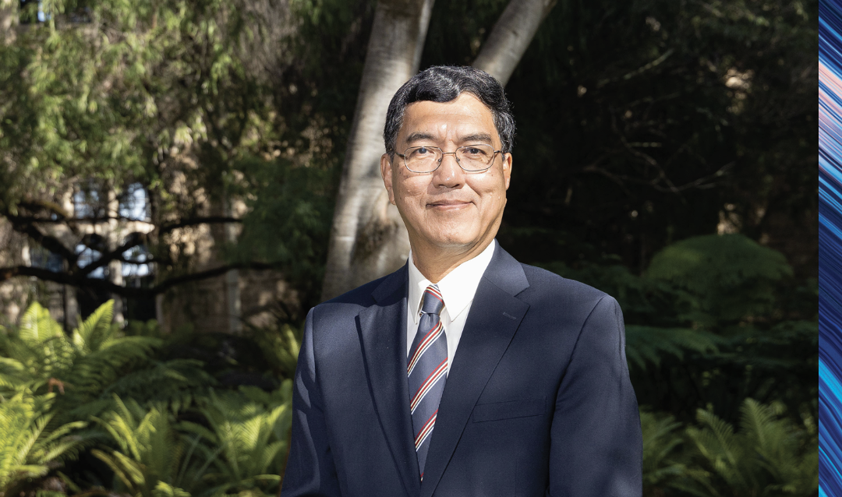

Universities do not rule the world, although we have done much to shape it. Despite all the stories of “ivory towers” and people who “don’t live in the real world”, most members of universities have a profound sense of their responsibilities to their communities – at the local, national and global level.
The University of Western Australia works with broad cross-sections of the State it was created to serve. The University works with farmers and miners, doctors and patients, teachers and students.
Our founding mission, enshrined in the University of Western Australia Act of 1911, deliberately links the words “prosperity and welfare”. The Parliament understood that there were “practical arts and liberal studies” which were needed to “advance the prosperity and welfare of the people”.
A goal of prosperity without a concern for welfare narrows the focus. If we are not concerned with the welfare of the people, all the people, no form of prosperity will be sustainable.
We are learning to live in a world interconnected in ways unimaginable to previous generations. Ideas and microbes can travel at unprecedented speed around the globe. A problem created in one part of the globe is unlikely to stay there.
Universities must be part of the solution: for all problems.
At UWA, we seek wisdom. We seek to discover how we can help Western Australia and the world solve the problems of sustainable development. How do we meet energy needs without threatening our future? How do we empower people equally, respecting communities of all kinds, and sacrificing none?
We are seeking wisdom in countless ways, some of which you can discover in the pages that follow: exploring the broadest issues and implications of climate change, clean energy technologies and healthy environments.

Professor Amit Chakma, Vice-Chancellor
The University of Western Australia

In focus

Can parents control their teens’ technology use to protect their sleep?
Teens who spend longer watching TV, playing video games and browsing the internet and social media tend to sleep less and are more prone to daytime sleepiness, but parental control of technology does little to protect their sleep, according to UWA researchers.
Contrary to popular belief the paper, published in Sleep Medicine, found a bi-directional relationship between technology use and sleep in adolescents.
Dr Cele Richardson from UWA’s School of Psychological Science and Centre for Sleep Science, and her colleagues at Macquarie University, carried out a study measuring teens’ sleep, technology use and parental control across three annual waves.
“The night owls in our study tended to use technology more over time,” Dr Richardson said. “This is really interesting as there is a growing appreciation that young people might actually be using technology as a sleep aid.”
Given many teens are not getting the hours of sleep recommended for their age, the study questioned whether parental control of technology use could help to protect adolescent sleep.
However, the researchers found that parental control of technology did not predict changes in time spent using technology nor adolescent sleep over two years.
Surprisingly, the more time teens spent using technology and the greater their preference for the evening and associated daytime sleepiness, the less parents perceived they had control over their teen’s technology use.
“Since parental control of technology use did not protect adolescent sleep, our results suggest the need to focus on finding creative ways in which adolescents themselves can mitigate their risk of inadequate sleep,” Dr Richardson said.

Imagination the key to a more rewarding life
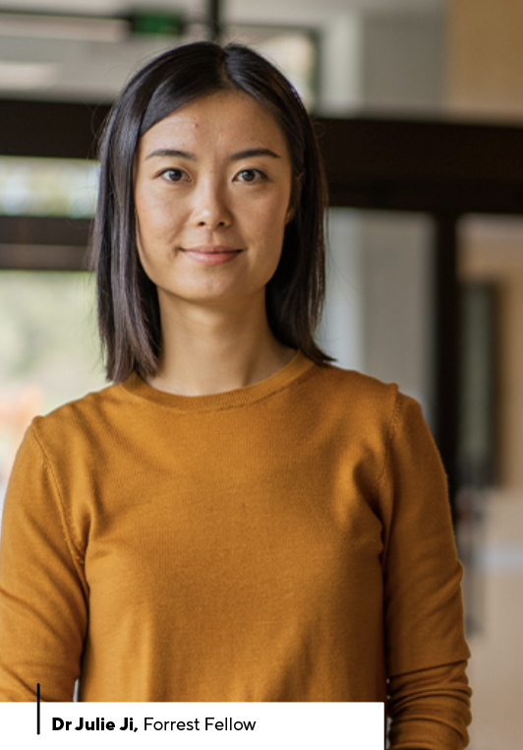
People struggling to motivate themselves to engage in activities that are good for them should tap into their imagination to visualise themselves carrying out the activity, according to new research from UWA.
Forrest Fellow Dr Julie Ji and her colleagues from UWA’s School of Psychological Science compared two strategies for motivating people to engage in pleasurable and achievement-oriented activities that they wanted to do more of in daily life.
The study, published in Behaviour Research and Therapy, found that visual imagination-based motivational thinking, but not verbal reasoning-based motivational thinking, led to higher frequencies of activity engagement over the next week compared to simply scheduling the activities into the diary.
Dr Ji said making use of the human capacity to imagine future experiences was more successful at motivating behaviour.
“Our findings suggest that vividly imagining yourself actually doing the activity in the near future and pre-experiencing the most rewarding moments of that activity appears to boost motivation,” Dr Ji said.
“In contrast, mentally going over all the reasons why you should exercise more, eat more healthily, be more social, and learn new things doesn’t seem to be very effective.
“Most interestingly, although both the visual imagining and analytical reasoning approaches increased people’s judgment of how rewarding the activity will be, visual imagining was unique in its capacity to evoke positive emotions, and this emotional impact, in turn, predicted a greater motivation increase.”

New evidence on how breastmilk prevents allergies
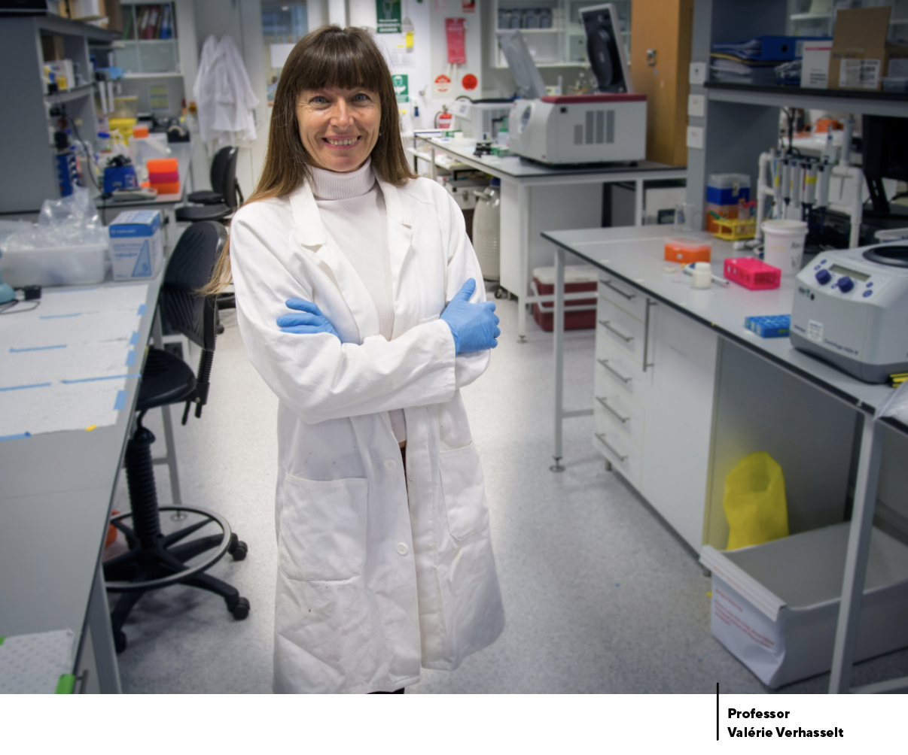
Mothers who breastfeed produce signals that influence the immune system development of their babies and help prevent future food allergies, according to new global research.
World-leading breastfeeding experts, from The Larsson-Rosenquist Foundation Centre for Immunology and Breastfeeding at UWA, Telethon Kids Institute and three German research institutions, published new evidence highlighting that the allergens in breastmilk could be key to educating a child’s immune response.
Ten per cent of children in Western countries already have a food allergy by the age of one and this evidence could help guide maternal health advice and alleviate the worldwide burden of allergic disease.
The findings, published in the Journal of Allergy and Clinical Immunology, supported the concept that being exposed to allergens in breastmilk was unique and very different from allergen exposure in non-breastfed infants.
Breastfed infants are exposed to multiple allergens, originating from maternal diet and the environment, likely to be found in their diet and environment after weaning.
If not breastfed, infants would not be exposed to most of these allergens before weaning and consequently would not receive this preparation to the external world.
In addition to the many allergens found in breastmilk compared to formula, Professor Valérie Verhasselt, the Larssen-Rosenquist Director of Centre of Research for Immunology and Breastfeeding at UWA and Telethon Kids Institute, said exposing infants to allergens through breastmilk rather than food was very different.
“In breastmilk, only a minute dosage would reach the child compared with when administered through food to the child,” Professor Verhasselt said.
“The allergen is also found pre-digested, bound to antibodies and surrounded by a ‘soup’ of molecules that can modulate the immune system. This may be especially designed for early life immune system education and preventing harm.”
Professor Verhasselt said a better understanding of the specificities of allergen exposure through breastmilk should lead to more evidence-based health interventions to prevent allergies in early life.
The support of the Family Larsson-Rosenquist Foundation is gratefully acknowledged.

Survey reveals mental health impact of Black Summer fires on emergency workers
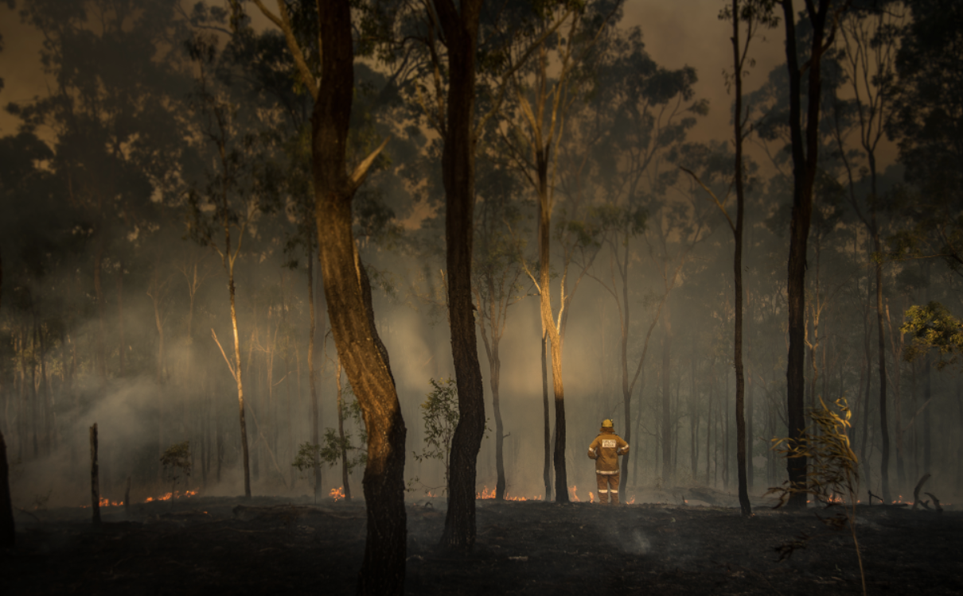
A new survey by the Graduate School of Education at UWA highlights the impacts of the 2019-20 Black Summer fires on the wellbeing of emergency services workers, with many responders reporting a high need for mental health support.
After the Fires study was led by UWA in partnership with Flinders University, Military and Emergency Services Health Australia (MESHA, part of The Hospital Research Foundation Group), Roy Morgan Research and the Bushfire and Natural Hazards Cooperative Research Centre.
It is estimated that 82,500 emergency workers including volunteers and employees were involved in responding to the natural disaster and 4,000 of those participated in the survey, which was funded by the Federal Government’s Medical Research Future Fund.
UWA co-lead researcher Associate Professor David Lawrence said the report underlined the need for governments and communities to consider how they would respond to increasingly frequent and severe events such as the Black Summer fires.
“While all emergency services agencies have policies and procedures in place to support their employees’ wellbeing and provide support to those with mental health issues, an important issue to consider is how to scale up the level of support available following major disasters,” Associate Professor Lawrence said.
The survey identified a third of volunteers and a quarter of employees had felt there was a time when their life was threatened when responding to the 2019-20 bushfires.
“We found that 4.6 per cent of volunteers and 5.5 per cent of employees had very high psychological distress indicative of serious mental illness, which equates to around 3,000 volunteers and 1,000 employees, compared to 4 per cent of the overall Australian population,” Associate Professor Lawrence said.
“The survey also revealed that rates of suicide ideation and suicide plans were about twice as high as in the general population.”
Of those who responded to the 2019-20 bushfires study, 4.5 per cent of volunteers and 5.1 per cent of employees had probable PTSD at the time of the survey, representing an estimated 2,900 volunteers and 920 employees.
After the Fires aims to address key gaps in knowledge about how to foster resilience and coping, and investigate how to deliver effective support for mental health and wellbeing to bushfire first responders.

Australians to help transform UK heritage collections through artificial intelligence
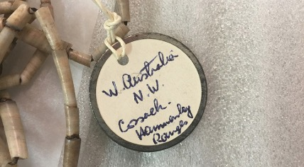
UWA is a partner in an innovative new project to harness artificial intelligence and emerging technologies to address challenges surrounding access to the UK’s culture and heritage collections.
Britain’s Arts and Humanities Research Council has announced $27m (£14.5m) in funding to Towards National Collection for the research and development of emerging technologies in order to connect the UK’s cultural artefacts and historical archives.
Collecting the West, which looks at what’s been collected from WA, is an Australian Research Council-funded project and a collaboration between UWA and Deakin University, in partnership with WA’s key collecting institutions and the British Museum.
Five Towards National Collection ARC Discovery Projects will receive funding and the Collecting the West team and the British Museum are two of the partners for the project The Sloane Lab: Looking back to build future shared collections.
The project, led by UWA’s Professor Alistair Paterson and Deakin’s Professor Andrea Witcomb, will focus on the vast collections of Anglo-Irish naturalist Sir Hans Sloane in public institutions.
Professor Paterson said researchers would work
with expert communities, including museum audiences, to link the present with the past to allow the connections between Sloane’s collections and catalogues to be
re-established.
The main outcome of the project will be a freely available, online digital lab — the Sloane lab — that will offer researchers, curators and the public new opportunities to search, explore, and engage critically with key questions about our digital cultural heritage.
In addition to innovative online access, the projects will generate artist commissions, community fellowships, computer simulations, and travelling exhibitions.

Broome’s mother of pearl shines a new light on the medical industry
Ground-breaking research from UWA has discovered the potential to create a bone substitute from silver-lipped pearl oysters in Broome.
New WA biotech company Marine Biomedical intends to develop medical products and devices including PearlBone from marine resources such as nacre, commonly known as mother of pearl, which are sustainably certified.
Co-inventor Professor Minghao Zheng, from UWA’s Medical School and Perron Institute, devoted many years to the development of the product and said its potential for orthopaedic applications could not be understated.
“Our work has proven that PearlBone substantially supports the process of new bone formation, compared to other synthetic bone substitutes in the market,” Professor Zheng said.
“The results to date are very encouraging — through PearlBone, there is a revolutionary opportunity to utilise the process of marine biomineralisation in lieu of traditional devices in orthopaedic, trauma and reconstructive surgical applications.”
Marine Biomedical was established through a partnership with local Broome pearling business Willie Creek Pearls, with research expertise through UWA’s Medical School and support from established biomedical business Orthocell Limited.
Willie Creek Pearls Chairman and Marine Biomedical partner Robert Banfield said he welcomed the opportunity to expand the opportunities for Broome’s internationally renowned pearling industry.
“Modern pearl farming has tended to view nacre as a by-product, but this opportunity to develop PearlBone from this incredible source material shines a light on a whole new opportunity for the pearl farming industry,” Mr Banfield said.
Marine Biomedical will continue the development of PearlBone and pursue regulatory approval for the product in several countries, including Australia, in the next three to four years.

Feature

Making waves to tackle climate change
By Annelies Gartner
Harnessing the power of the ocean and utilising its unique biodiversity to create renewable energy and find sustainable food sources are important tools in tackling climate change.

The Wave Energy Research Centre at UWA in Albany, Western Australia, was founded in 2018 to uncover the best methods to generate renewable energy from the ocean.
The latest round of funding UWA received was for a joint $4.8 million project between the WA Government and the Blue Economy Cooperative Research Centre to construct and deploy a wave energy convertor in Albany’s King George Sound.
“It will come with the centre also showing we are doing more than wave energy,” explains Dr Wiebke Ebeling, Centre Manager at UWA Oceans Graduate School.
“We’ve also become active in tidal energy and offshore wind energy research, so we’re now rebranding to Marine Energy Research Australia (MERA) which better reflects our capabilities rather than limiting us to wave energy research.
“We are pushing UWA’s reputation into the renewables sector and embracing all things offshore engineering in the real world space.”
Climate change causes rising sea levels, coastal erosion, biodiversity loss as well as salinisation of aquifers, wetlands and estuaries. And coastal and remote communities are emerging as areas that have the potential to be big benefiters from marine energy.
Dr Ebeling cites the recent storms that damaged Busselton jetty and caused beach erosion along the coast as an example.
“A lot of our research is highly applicable to monitoring coastline and finding baseline data in the context of climate change so we understand the impact of more severe weather,” she says.
“In areas where the coastline is taking too much of a beating you can put wave energy convertors in the water to create a much softer wave run up and protect the beaches.”
Dr Ebeling says there is also the option to use marine energy in collation with desalination units to produce fresh water from salt water and further reduce our carbon footprint.
“We often forget that trucking diesel and trucking freshwater into remote communities is a huge, huge cost and might be very unreliable at times,” she says.
The process of desalinating water also has the ability to create another decarbonisation fuel – hydrogen.
“It is still in the research and development space but the idea is if you’re operating the electrolyser you might as well produce the hydrogen where it naturally happens,” Dr Ebeling says.
“You could have units that produce electricity to power – an electrolyser that splits water into oxygen and hydrogen and also creates desalinated water.
“You can have a merry mix of all the good things in the world especially when you’re quite off the grid.”
The demonstration site in King George Sound has also shown ways of reducing the carbon footprint created by some aquaculture.
“The site in King George Sound is very much wind-driven, so it’s a surface riding technology, and it is in absolute proximity to the shellfish hatchery,” Dr Ebeling explains.
“The shellfish hatchery uses millions of litres of water and pumps to keep all the oysters and algae happy and has a strong carbon footprint attached to it at the moment.
“The idea is if we want to decarbonise aquaculture is to use ocean energy – have an expendable energy source to power the pumps and heaters or whatever is needed.”
But there is also the potential for other forms of aquaculture, in particular seaweed farming, to reduce emissions.
Dr John Statton, from UWA’s School of Biological Sciences, says we are very much in our infancy in Australia in regards to seaweed farming but it is more a green form of aquaculture “in the sense that it is essentially very middle input into systems”.
“We are not feeding these seaweeds any feeds to keep them alive, they are extracting nutrients out of the water but they are also photosynthesising so drawing carbon out of the water,” Dr Statton explains.
“Which, depending on the size of the area, can actually help remove CO2 or carbon from the water and essentially act as a buffer for the atmosphere if we’re talking massive scales.
“There is also a potential for seaweed fragments or bits that have broken off from seaweed farms to enter into marine sediments - either in seagrass or mangrove or deep ocean - where they get incorporated into the sediments and in that sense would be a form or supply of blue carbon.”
Dr Statton says a fish or shellfish farm wanting to reduce nutrient effluent could put a skirt of seaweed around the farms as a way of soaking up the excess nutrients.
Seaweed can also be used to produce pharmaceutical, nutraceuticals and food but recent research into its use as supplement in cattle feed has presented a big positive for the environment.
“When a small amount of this seaweed is included in livestock feed, so Ruminant livestock, it actually reduces their methane production from anywhere between 80 and up to 98 per cent – so it’s a big game changer in that sense,” says Dr Statton, who is researching a species of seaweed called Asparagopsis.
He says less than one per cent of the feed weight per day needs to be substituted with the dry seaweed which not only reduces carbon it also increases the productivity of the cattle.
“So the research that is coming out of CSIRO – its spin-off company which is FutureFeed – has demonstrated that they are getting on average about 20 to 25 per cent increase in productivity when adding this seaweed to their feed,” he says.
“This has mostly been focussed on beef, so biomass, but there are definitely benefits to milk production as well as sheep and wool quality and meat production.
“So when the seaweed becomes available it would probably be a smart idea to jump on board and be involved in the early niche market that is going to come out of this which is green, fast-produced cattle.”
And not only are there benefits to the environment and the livestock from seaweed there is also the potential for big economic gains.
“If someone is able to commercially farm the species (Asparagopsis) within the next year and is able to produce thousands of tonnes you’d easily be cracking the $10 – $100 million within a five-year time frame,” he explains. “It’s a highly-valued species at the moment and there would be a swift turn around between exports and what we are able to produce locally.”
Commenting on the new WERC and algal aquaculture developments, UWA Oceans Institute director Associate Professor Julian Partridge emphasised the timeliness of these projects.
“The Oceans Institute has identified the development of marine renewable energy and algal aquaculture as two of the Institute’s priorities for 2022,” Associate Professor Partridge says.
“UWA Oceans Institute members have high-level expertise and a wide range of skills that can be brought to bear in both these areas. This is based on the core marine engineering or marine biology that underpin these particular projects, but extends to encompass the many critical additional elements where expertise is needed, including socio-economics, legal frameworks, and policy development.
Associate Professor Partridge believes a multidisciplinary approach is essential if these nascent activities are to be taken from pilot stage to become large-scale industries in Western Australia.
“The rapid formation of expert multidisciplinary teams is exactly what the UWA Oceans Institute can do,” he says.
“There is great potential for the rapid expansion of both marine renewable energy and algal aquaculture in Western Australia. The Oceans Institute is committed to supporting the UWA researchers leading these important projects, particularly by the engagement with external stakeholders in regions, government, and industry.”

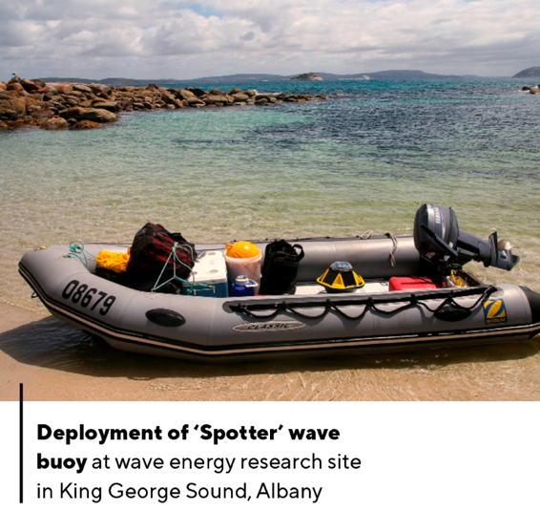
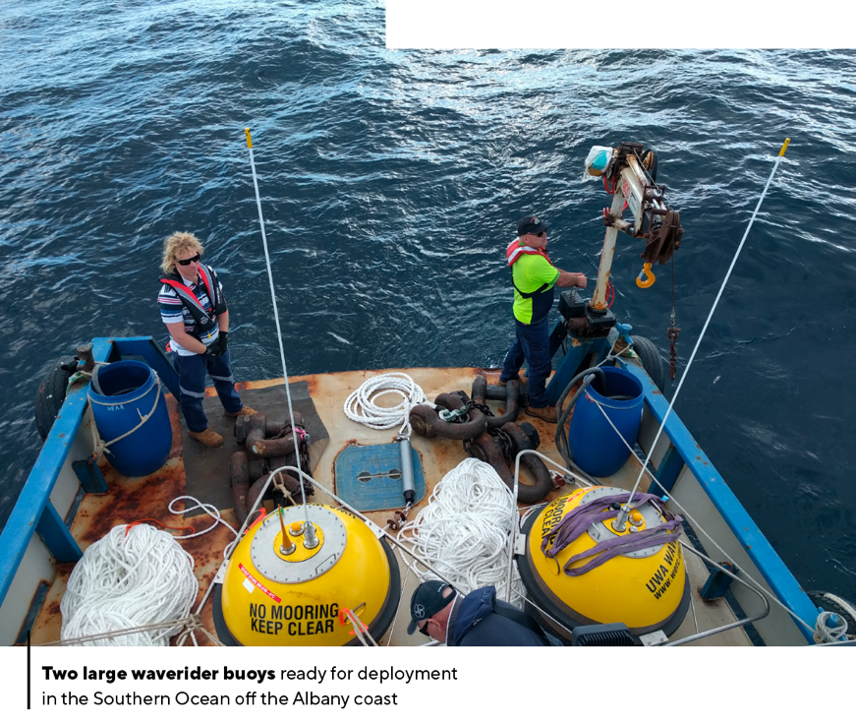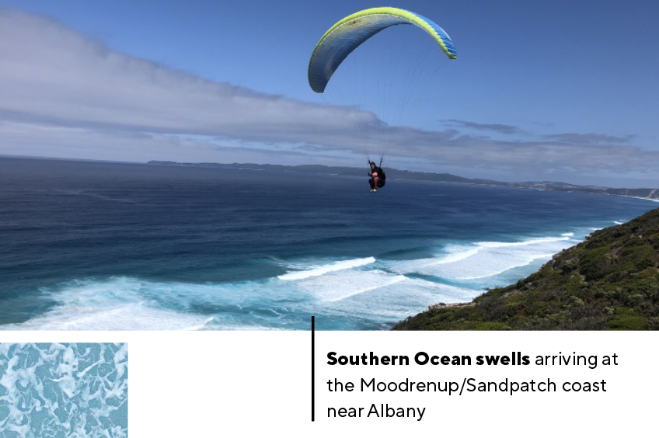

FEATURE

Are we prepared?
By Liz McGrath
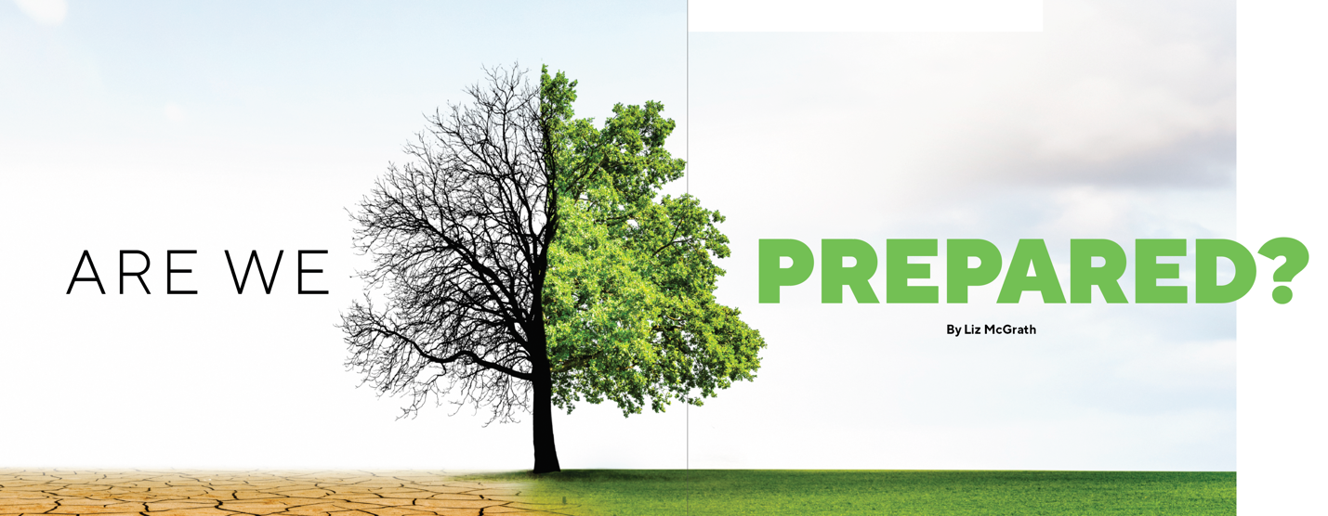
The global challenges of climate change aren’t only a focus for researchers, but are also forcing universities to educate and train students differently. They must do so in order to remain fit for purpose.
When UWA’s Public Policy Institute published The Preparedness Report, a first-of-its-kind report on climate change, it pointed to the “large and tricky challenges” facing professions and disciplines as they, and the practitioners they train and educate, come to terms with what global warming means for them.
Institute Director, Professor Shamit Saggar, argues that while “Australia’s politicians are increasingly on the back foot”, this was something universities and professions could not risk doing.
“Many new skills and competencies will have to be taught – for example, the need to engineer heat-tolerant public transport systems and plan water-sensitive cities,” Professor Saggar says.
“Fresh mechanisms will be needed to ensure the value of current expertise, such as actuaries’ capacity to model commercial and household risk for insurance purposes. Greater use of crossdisciplinary collaboration will be needed too, in areas such as building design and construction.”
The ‘Prep Report’ put the spotlight on six areas; law and the legal profession, economics, architecture, healthcare, and engineering. We take a look at the nature and extent of retooling in two – architecture and healthcare – and how they might prepare to meet the challenges ahead.
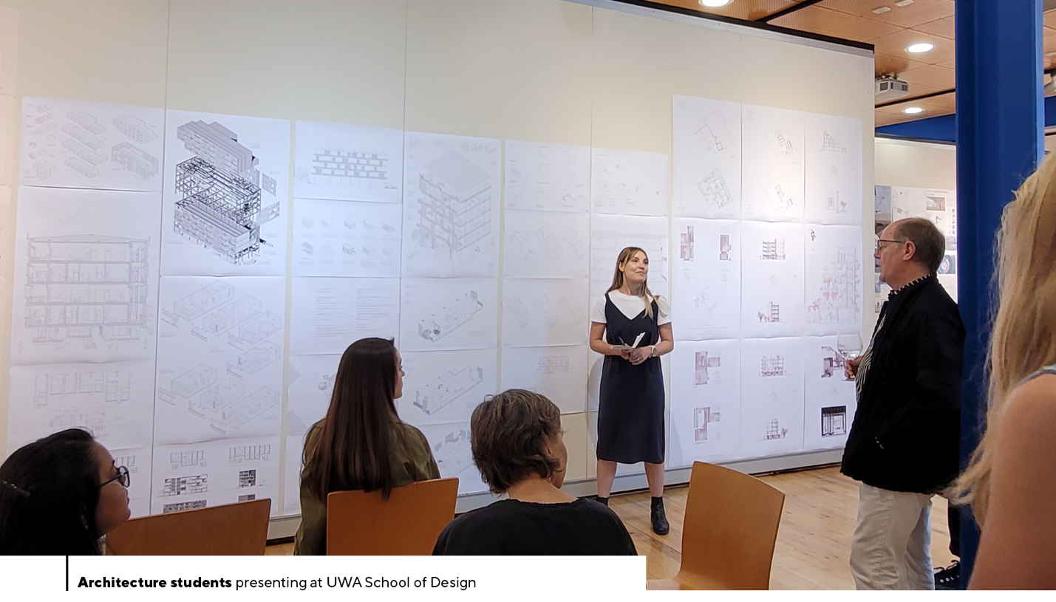

Ensuring sustainability in architecture
Shopping centres aren’t usually synonymous with sustainability; however in Burwood, an eastern suburb of Melbourne, there’s a mall different to most others.
Hyped as ‘the world’s most sustainable shopping centre’, Burwood Brickworks has managed to achieve Living Building Challenge status, described by the International Living Future Institute – the global authority that administers it – as “the ultimate green building standard that can be applied to any building type around the world”.
For Gemma Hohnen, architecture consultant and tutor with UWA’s School of Design, it sets a benchmark for design that Australian architects should be aspiring to and follows their mass pledge to become carbon neutral in the wake of the 2019/20 summer of bushfires.
“Brickworks sits underneath a 2000 sq m urban rooftop farm, where the restaurant sources its produce; it’s powered by renewable sources; and grey and black water is treated and recycled on site,” Ms Hohnen says.
“This example of ‘regenerative design’, mitigating the impact of construction and operation, design continues right down to the products used in the nail salon at the centre which are non-toxic. It pushes the boundaries demonstrating what can be done when we rethink buildings from the ground up.”
Architects have a big role to play in reducing CO2 emissions, argues the architecture consultant, with the built environment contributing roughly 40 per cent of greenhouse gas locally.
But despite the Australian Architects Declare Climate and Biodiversity Emergency (AAD) being launched in 2019 in response to the Special Report by the Intergovernmental Panel on Climate Change (IPCC), there’s still a long way to go, she says.
“For the majority of practising architects, knowledge of designing to zero carbon requires education, yet, faced with maintaining a steady workflow, most default to the business-as-usual approach.”
She points to the bleak analysis of Scott McAulay, founder and coordinator of the Anthropocene Architecture School in Scotland: “The contemporary architectural education system – through both academia and continuing professional development (CPD) – does not equip current practitioners nor the practitioners of the future to work within the ongoing climate emergency. This must be addressed urgently.”
Education, Ms Hohnen says, can and must do more to equip future architects to address this knowledge gap.
“There are many elements that can be addressed in design to optimise the performance of buildings and reduce embodied carbon – design decisions that are so embedded the outcome may not look like typical associations with sustainability,” she says.
“Students are in a unique position of not only being able to test and evaluate new design solutions, but to rethink what these solutions might actually be and how we might use and engage with our built environment. I believe this gives our students agency in a rapidly changing future.”
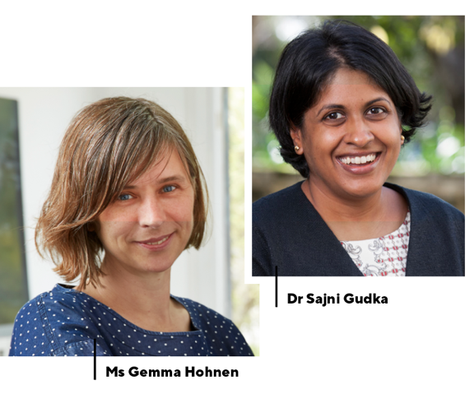
So, what will business as usual look like for the profession and for students?
“The National Standard of Competency for Architects 2022 draft now requires all Architects and Graduates of Architecture to be capable of designing net zero buildings,” Ms Hohnen says.
“UWA — and the higher education sector more broadly — needs to deliver climate and carbon-literate graduates of architecture, who are conversant with what’s necessary, who understand what sustainability means in the context of the climate crisis, and who know what the profession can and should provide for climate mitigation and adaptation.
“The students who choose my studio know that we can make change happen and that we can do something other than business as usual.”
Investing in health is divesting from harm
Our changing climate means we’ll face many different faces of public health emergencies, warns Dr Sajni Gudka, Director of the Urban Impact Project and Adjunct Research Fellow.
“All over the world we will get more infectious diseases, more heat stress, more mental illness, less food and water and poorer nutrition,” she says.
“The InterAction Council, which consists of former Heads of Government and academics at the University of Southampton in the UK, published a manifesto headed Securing A Healthy Planet For All in which they reasoned that if they were to consider planet Earth as a patient, as health professionals it would be diagnosed as critically sick.”
Dr Gudka says there are many scientific and evidence-based frameworks available that provide health and medical disciplines with strategic and specific guidance on responding to the emergency.
“A cross-curriculum inquiry is needed into ways in which universities could take bold and courageous climate action and how health and medical schools could use their position to influence academic institutions to invest in health and divest from harm,” she says, with four immediate suggestions.
1. Teach the science
Public health and medical schools could replicate the approaches used in dealing with other major threats to health such as smoking, drug and alcohol misuse, obesity and sugar intake, Dr Gudka says, taking leadership in educating students on the impacts of climate change, exposures and vulnerabilities through the introduction of a ‘Climate Health, Without Harm’ unit.
2. Invest in health
Universities should actively look for and create opportunities to mobilise new cross-sectoral partnerships and collaborations and to apply global metrics, data and health mitigation and adaption strategies to climate hazards and population needs that are locally specific, says the public health expert. She suggests public health educators and researchers integrate Health Impact Assessments into their work, providing expertise to other research groups within and outside the healthcare sector.
3. Divest from harm
“If we start to acknowledge, understand and openly talk about the systematic and intertwined complex nature of fossil fuels as a public health emergency, we’ll find new ways to invest in human and planetary health, and divest support, research, funding and our day-to-day reliance on fossil fuels – just as we did with Big Tobacco,” Dr Gudka says.
This could be done by creating public health campaigns and advocacy tools, with a focus on positioning fossil fuels as the next new Big Tobacco, responding responsibly to the climate emergency and divesting support, research and funding from fossil fuel industries, she says.
4. Communicate the science
Health and medical professionals should fill an essential role in communicating the health risks of climate change and implementing a robust response which will improve human health and wellbeing – across universities, in all health sectors and in all communities, Dr Gudka says, warning “the threats and challenges of climate are great, and time is short.”

FEATURE

Born out of Red Desert Dust and Determination
By Liz McGrath

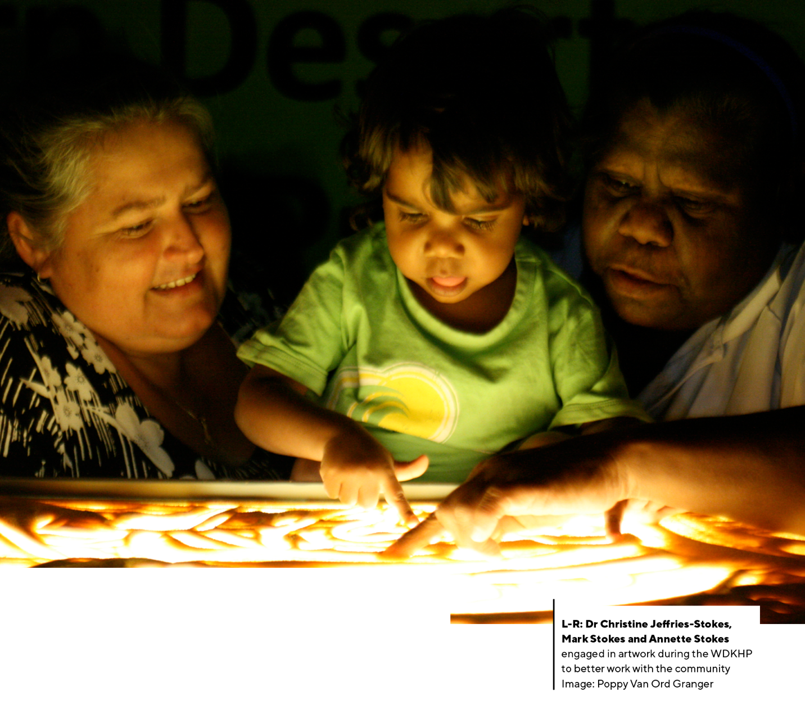

The Western Desert Kidney Health Project is a Rural Clinical School of Western Australia success story. A tale of 10 remote communities and local and state organisations that came together in a bold attempt to reduce diabetes and kidney disease in WA’s Goldfields and Western Desert.

At its centre – a team of Aboriginal health workers, researchers, artists, medical students and doctors who covered an area bigger than the state of Victoria, starting 500km east of Perth and extending 2000km to the border with South Australia.
Also drafted to play an important role, Fremantle Dockers’ AFL footballer, Sam Switkowski, who is in his final year of an environmental engineering degree at RMIT University.

How it all began and ‘Mara Yungu’
It was a series of conversations at funerals, explains Dr Christine Jeffries-Stokes from UWA’s Medical School and the Rural Clinical School of WA, which formed the genesis of the project.
“These were funerals of community members who’d died from kidney disease, diabetes or associated complications,” says the paediatrician who has worked in clinical practice and research in the Goldfields for more than 25 years.
“Type 2 diabetes is the leading cause of avoidable mortality for Aboriginal people here, accounting for 20 per cent of deaths. For kidney disease it’s six per cent – the area is estimated to have the second highest rate of end-stage kidney disease in Australia.
“The community wanted something to be done to prevent this loss of life and came to us in the hope that with our skills and knowledge and our strong local connection, we may be able to help.”
The ‘we’ included Dr Jeffries-Stokes’ sister-in-law Annette Stokes AM, a senior woman of the three main tribal groups for the region – the Wongutha, Mulba-Ngadu and Anagu tribes – and an accomplished artist and musician.
Ms Stokes' cultural standing meant she was able to talk frankly to senior members and elders as the ground-breaking study was scoped out; consulting around campfires, in kitchens over cups of tea, in art gatherings and at formal workshops.
“The study communities were small and in remote and very remote areas of Australia, with extremes of temperature, weather and facilities, so the practical challenges were great and a lot of commitment and time had to be given to developing relationships and engaging fully with the community,” Dr Jeffries-Stokes explains.
The concept of ‘Mara Yungu’, which roughly translates to ‘offer your hand’, was also important in the study design. While it has many overlapping meanings, for the Goldfields and Western Desert tribal groups, it implies an opening of spirit and a sharing of trust.
“For our project it meant offering your hand to help, a process of two-way learning where people contribute different skills or knowledge to solve a common problem.”

Artists and dancers join the study team
Between 2010 and 2014, the project team visited more than 30 community residences from Norseman to Tjuntjuntjara, spending a fortnight in each community annually and carrying out health assessments on 597 adults and 502 children, including almost 80 per cent of the total local Aboriginal population.
“We collected health data using a mobile clinic truck equipped with point-of-care machines,” Dr Jeffries-Stokes says.
“Medical histories were recorded on paper, usually in a private but open air environment, which was significant culturally because it demonstrated privacy but not secrecy.
“Many Aboriginal communities are fatigued by research that apparently returns little but bad news, so the challenge was to find ways of engaging and lifting the spirits of members while collecting this sensitive data in culturally secure ways,” she adds.
To meet that challenge, a decision was made to have artists and dancers join of the study team of Aboriginal health workers, researchers, medical students and doctors.
Traditional sand drawings, animation, sculpture and dance were used to deliver key health messages, setting new standards for innovative community-based research.

Spotlight on poor quality drinking water
The researchers found that risk factors for kidney disease and type 2 diabetes were present in participants of all ages, including children as young as two, with no significant difference between Aboriginal and non-Aboriginal children, suggesting that it might be common exposures that are to blame, rather than ethnicity.
Aboriginal and non-Aboriginal adults had twice the burden of type 2 diabetes than the standard Australian population and 51 per cent of Aboriginal adults and 27 per cent of non-Aboriginal adults had at least one marker of kidney disease. Aboriginal women were the highest risk group.
Dr Jeffries-Stokes said high levels of acid and blood in the urine of participants suggested factors contributing to chronic metabolic acidosis and inflammation or irritation of the urinary tract needed to be explored.
Of all the contributing factors, drinking water was of particular concern.
“In most of the study areas, drinking water is heavily contaminated with nitrates and, in at least one community, uranium. One of the effects of uranium ingestion is kidney inflammation and damage, which is exacerbated by the presence of nitrate and the formation of uranyl nitrate.
“In two communities — Mulga Queen and Mount Margaret — a 2020 review by the Western Australian Auditor General showed there’d been no improvement in water quality over the past five years, and nitrate levels remained above international and Australian health guidelines,” she says.

Fremantle Docker Sam and the quest for fresh water
Mr Sam Switkowski is part of a team from Optimos, D2K Information, RMIT, UWA and the University of Queensland that has been designing and testing pilot technologies to remove nitrate from drinking water.
As the only WA-based person in the RMIT team who’d been tasked with looking at water treatment options, he was able to visit Mulga Queen and surrounding communities in June to take water samples and speak directly to locals about their drinking water challenges.
“The other three members of my team are currently testing three potential water treatment systems at RMIT in Melbourne to work out which will be the most efficient and the most feasible to implement,” Mr Switkowski says.
“For me personally, it’s been fantastic to experience another side of WA and to have been welcomed into several indigenous communities. It’s clear they aren’t getting the essential services they deserve, and as a result their health and wellbeing is at a higher risk.
“I’m incredibly grateful for the experience the project has given me and the opportunity that RMIT has provided in doing something purposeful and helpful for indigenous people. It’s ignited a passion in me and a determination to make a positive impact to those who don’t have access to clean and safe drinking water.”
Dr Jeffries-Stokes says the increasing burden of kidney disease and type 2 diabetes is a global problem, especially for remote and Indigenous populations.
“Until our study there hadn’t been too much investigation into the reasons why this was happening in the Goldfields and Western Desert,” she says.
“As well as us looking at drinking water, communities have been able to use the health information and support that we provided to make changes in other areas. All five towns now, for example, have a grocery store with an emphasis on fresh foods.
“Two towns and two communities have also planted fruit trees in public gardens and the schools have new fruit and vegetable gardening programs.
“At the same time as we did this study, our aim was to develop research skills in the community, while developing community capacity to combat these diseases and contribute to ‘Pulkurlkpa’ – a deeply soul-felt sense of joy, hope, optimism and resilience. I hope we achieved that.”
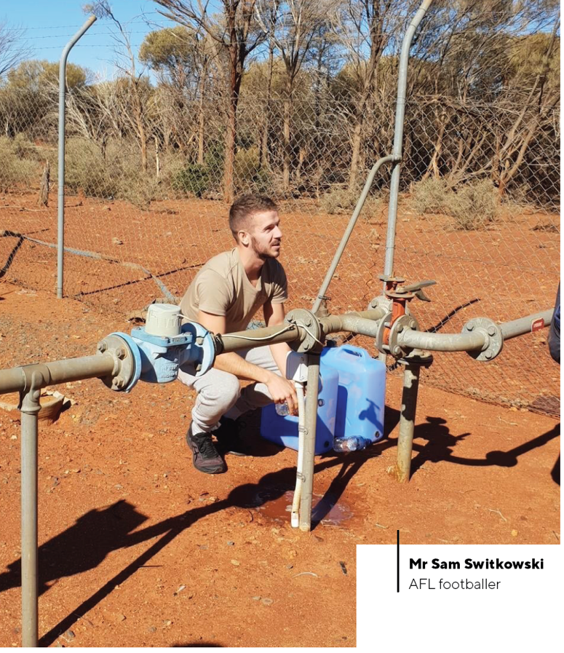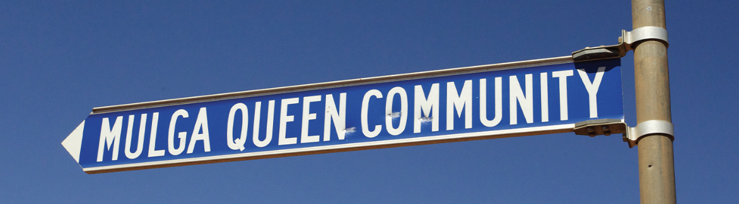

FEATURE

UWA’S Energy Smart Future
By Dr Geraldine Tan and Verity Chia
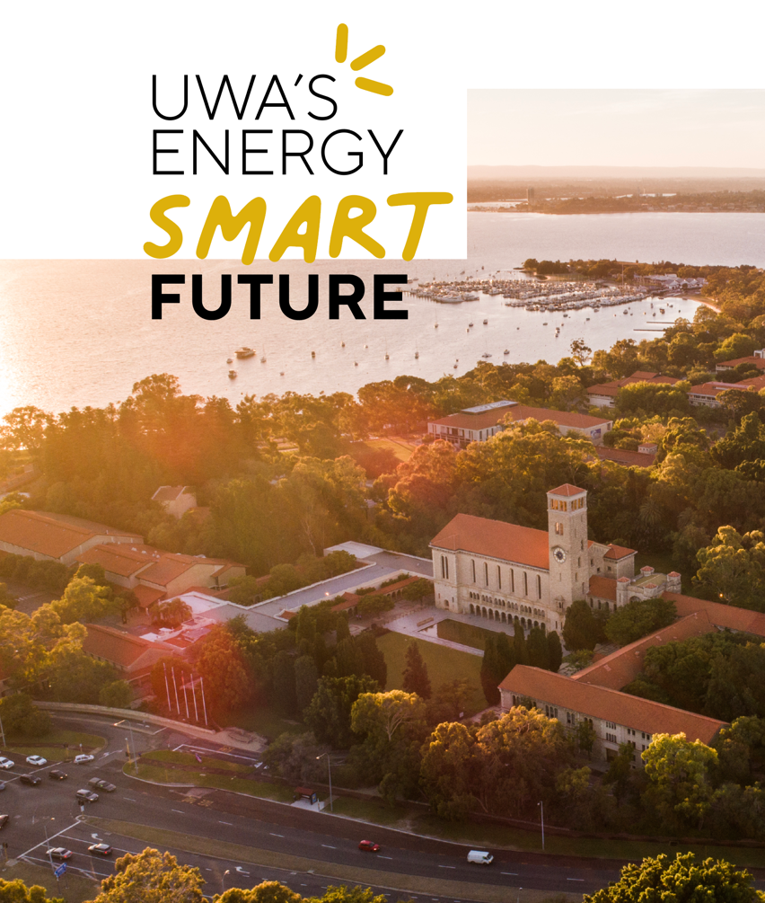
UWA is on track to become the first university in Western Australia – and one of a handful of universities nationally – to achieve renewable energy offsets for 100 per cent of its electricity requirements from the grid.
The announcement comes after the University signed an agreement that will see its expected electricity supply from the grid offset entirely from renewables by 2025.
The shift to renewables is part of UWA’s commitment to achieving energy neutrality by 2025. It’s also part of the Energy Smart Campus initiative, which uses the University’s campus as a ‘living laboratory’, in which everyone is invited to have a stake in the energy future of the campus, from reducing consumption to developing emerging technologies.
Led by the University’s Campus Management team, the initiative brings together teaching, research and expertise from professional sectors around a central premise: the campus.

Impressive insights
The University’s powerful energy reporting platform, developed by former UWA data scientist Dr Jason Hamer (PhD ’16), provides information on the electrical consumption of buildings, electrical generation from solar photovoltaics and information on the central thermal energy system (for air conditioning).
Dr Hamer explains the platform has a sophisticated deep-learning forecast model that can predict the campus energy load at 30-minute intervals one day in advance – with an accuracy of 96 per cent.
“This deep-learning model is constantly adjusting to account for data glitches and anomalies, such as the COVID-19 lockdowns,” Dr Hamer said.
“It enables the University to make operational decisions ahead of time, and could eventually be used to automate some processes, creating a self-operating and self-learning campus.”
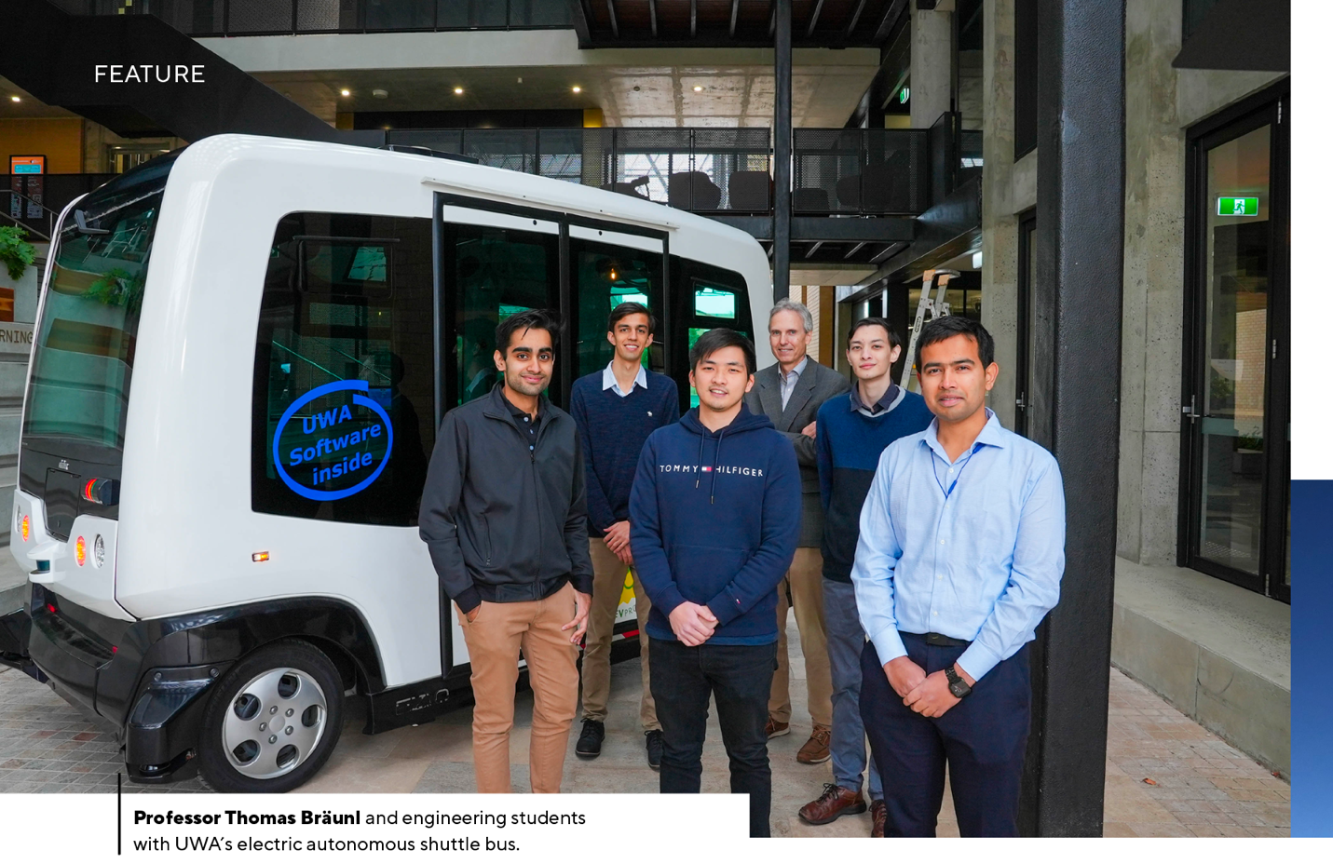

Where will UWA’s electricity come from?
UWA has entered into an agreement with Synergy to invest in the supply of renewable electricity from the Warradarge Wind Farm in WA’s Mid West town of Eneabba. By 2025, all of UWA’s expected electricity needs from the grid will be offset by electricity produced from renewable sources, principally the Warradarge Wind Farm.
The University’s visionary approach to energy procurement hasn’t only considered the traditional objective of ‘value for money’. It’s also delivering on other strategic objectives such as energy neutrality (and by extension, carbon neutrality), and the creation of teaching and research opportunities and partnerships.

Buying green is just the start
While the University can achieve its goal of energy neutrality through the purchase of off-site renewable energy or carbon offsets, the real opportunity to ensure long-term energy supply and cost independence lies within the campus footprint and adopting ‘behind-the-meter’ interventions (meaning the University draws less electricity from the grid).
The Crawley campus is serviced by various energy networks comprising generation, distribution and storage of electrical, chemical (natural gas) and thermal energy (chilled water for air conditioning).
The interaction between these forms of energy (for example, conversion of electrical to thermal energy at the Central Energy Plant), and the availability of energy storage enables the University to effectively manage its energy profile.
UWA’s Principal Engineer Stuart Downes said the campus’ highly interconnected ‘ringed’ distribution network offered greater flexibility and resilience in the operation of its energy systems.
“From the very start, the Crawley campus was built on sound engineering principles with efficiency, reliability and flexibility at the forefront of its planning and design,” Mr Downes said.
“We have an opportunity to capitalise on this foundation and consider additional principles, such as neutrality, innovation and connectivity.”

Wide-ranging impact
When it comes to building an Energy Smart Campus, UWA’s Energy and Sustainability Manager Dr Geraldine Tan (BCom, BE ‘97, PhD ‘05) emphasised the importance of integrating the University’s campus operations with its core pillars of teaching, research and engagement.
“There is an opportunity to use the campus as a testbed which, if done collaboratively, can benefit operations as well as enhance the teaching and research offerings of the University,” Dr Tan said.
“The University already has a range of exciting research projects that can be applied on campus, from the introduction of electric vehicle fast charging stations, to growing battery industries in Australia and finding better ways to heat and cool buildings.”
One of the benefits for students, staff and visitors is the ability to charge electric cars on campus.
Professor Thomas Bräunl from the School of Engineering is leading the Renewable Energy Vehicle Project (REV). The project team recently installed a dual Siemens SICHARGE D 160kW electric vehicle (EV) fast charging unit at the EZONE UWA Student Hub. The new unit can charge an electric vehicle more than three times faster than the existing DC charger at UWA’s University Club.
The REV team, together with transport planning expert Associate Professor Doina Olaru, is studying consumer response to changes in EV charging tariffs, especially the introduction of time-of-use energy tariffs, which reflect the University’s own structure and the State electricity grid’s energy generation profile.
“We know the two biggest barriers to electric vehicle ownership are cost and lack of adequate charging infrastructure,” Associate Professor Olaru said.
“By making electric vehicle charging cheaper during the middle of the day – in the same way that standard electricity use often is – we can study the trade-offs that electric vehicle owners (and aspiring owners) make between purchasing and running costs.”
Other projects within the School of Engineering aim to harness research and industry expertise to enable the growth of battery industries within Australia; examine the decentralisation of the electricity grid using rooftop solar photovoltaics, electric vehicles, and electric heat pump water heaters to manage household energy loads; and explore alternative options for heating and cooling homes in Perth’s unique environment.
Across the University, staff and students are coming together to collaborate on sustainability initiatives. Sustainability and microgrid expert Adjunct Professor Bill Grace (BE ‘78) has contributed to energy modelling and renewable energy procurement for UWA’s Energy Smart Campus. More than 300 staff have taken part in the Green Impact program, improving the environmental performance of their workspaces through initiatives such as energy saving campaigns and adopting endangered animals. Meanwhile, students have signed up to be Green Impact assistants and auditors and undertook McCusker Centre for Citizenship internships to work on sustainability and carbon neutral projects, and 70 staff and students rode to campus to celebrate Ride to Work Day in October.
While there’s no shortage of expertise or passion among the University community, the Energy Smart Campus also extends to collaboration with external partners, including the University’s energy retailers and network providers.
When it comes to choosing suitable partners for UWA’s Energy Smart Campus the number one priority, according to Dr Tan, is ensuring that partners share the University’s vision of energy neutrality, and are open to exploring innovative energy and carbon solutions.
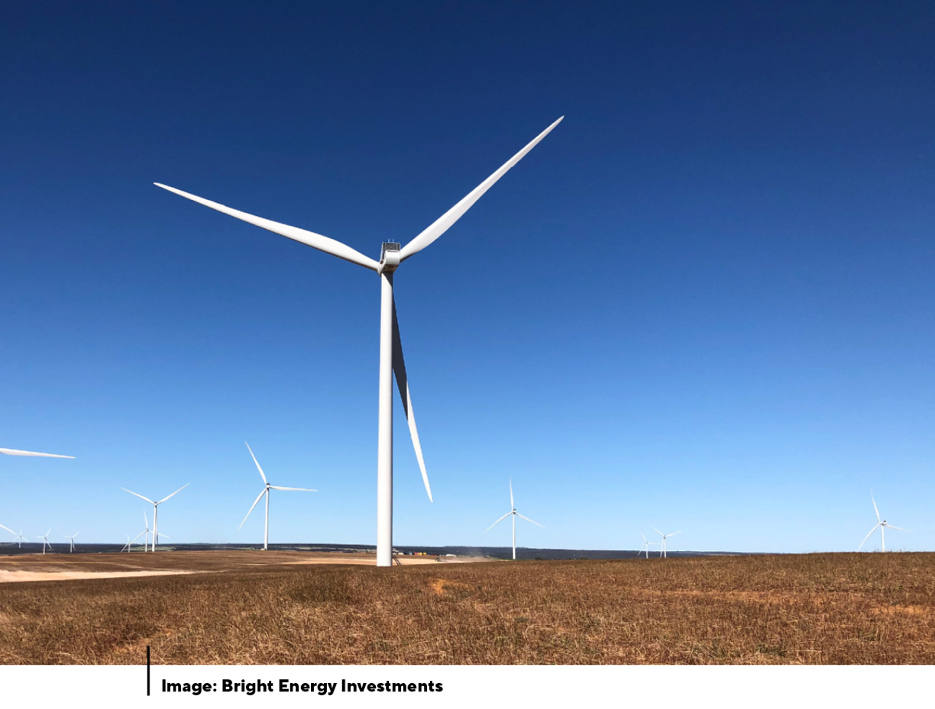

A powerful commitment
In 2019, the University released its Strategic Plan 2020-25, in which it committed to creating a more clean, green and sustainable campus and becoming energy neutral by 2025. Fast forward two years, and that ambition is likely to be achieved.
Campus Management Director Trevor Humphreys says the Energy Smart Campus – enabled through collaboration between professional and academic staff – is an important step towards UWA achieving its carbon neutral goals and addressing climate action.

THOUGHT LEADERSHIP

Why we must clean up the EARTH
By Julian Cribb AM FRSA FTSE (BA ’71) science author, co-founder, Council for the Human Future
Humans emit more than 200 billion tonnes of chemical substances a year, in a toxic avalanche that is injuring people and life everywhere on the planet.

Earth, and all life on it, are being saturated with man-made chemicals in an event unlike anything in the planet’s entire history.
Every moment of our lives we are exposed to thousands of these substances. They enter our bodies with each breath, meal or drink we take, the clothes and cosmetics we wear, the things we encounter every day in our homes, workplaces and travel. They affect every person, every day.
The poisoning of our planet through man-made chemical emissions is probably the largest human impact – and the one that is least understood or regulated. It is one of the 10 major existential risks now confronting humanity. It has mostly occurred in just the past two generations.
Recent assessments find there are more than 350,000 man-made chemicals in existence. The US Department of Health estimates 2000 new chemicals are being released every year. The UN Environment Program warns most of these have never been screened for human health safety.
The World Health Organisation estimates that 13.7 million people – one in five – die every year from diseases caused by ‘air, water and soil pollution, chemical exposures, climate change and ultraviolet radiation’, all of which result from human activity.
Examples of the toxic avalanche include: manufactured chemicals (2.5 billion tonnes a year); hazardous waste (400 mt/yr); coal, oil, gas (15 billion tonnes a year); lost soil (75 Gt/yr); metals and materials (75 Gt/yr); mining and mineral wastes (40-90 billion tonnes a year) and water (mostly contaminated with above wastes at 9 trillion tonnes a year).
Industrial toxins are now routinely found in new-born babies, in mother’s milk, in the food chain, in domestic drinking water worldwide. They have been detected from the peak of Mt Everest (where the snow is so polluted it doesn’t meet drinking water standards) to the depths of the oceans, from the hearts of our cities to the remotest islands.
The mercury found in the fish we eat is fallout from the burning of coal, and increases every year. Our seafood and marine life are contaminated with plastics made from petroleum.
There is global concern at the death of honeybees from 5 million tonnes of agricultural pesticides and the potential impact on the world food supply, as well as all insect life – and on the birds, frogs and fish which in turn depend on insects.
An issue largely overlooked by governments and corporations is that chemicals act in combination, occur in mixtures and undergo constant change. A single chemical may not occur in toxic amounts in one place – but combined with thousands of other chemicals it may contribute a much larger risk to the health and safety of the whole population and the environment that supports it.
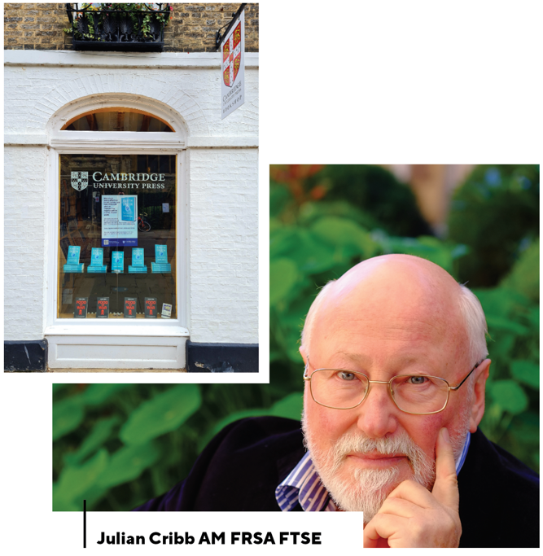
Medical science is increasingly linking issues such as obesity, cancers, heart disease and brain disorders such as autism, ADHD, depression and loss of intelligence to the growing flood of toxic substances to which humans are exposed daily.
Despite attempts to regulate chemical use, only 21 out of 350,000 chemicals have so far been banned. In many countries the petrochemical sector is persuading government to roll back the laws that protect public health, in the interest of profit.
The good news is that solutions to the threat of global poisoning exist, but they require worldwide co-operation by consumers, government, civil society and industry.
In Earth Detox I propose a new human right – a Right Not To Be Poisoned. Without such a right, there will never again be a day in history when humans are free from man-made poisons.
We also need a global alliance of consumers and concerned citizens prepared to reject toxic products or products made with toxic processes – and so give industry the economic incentive to switch to ‘green chemistry’ and other safer systems.
Communities the world over need to move as fast as possible to policies of ‘zero waste’, where nothing is discarded but everything is either re-used or toxic waste is made safe.
Earth has been poisoned because we, as consumers, send our dollar demands to industry to make things as cheaply as possible. This demand takes no account of the damage to human life and health that unbridled chemical use entails, including the 13.7 million annual deaths and 602 million disabilities it causes. We are all, in a sense, getting away with murder.
If consumers demand safe, healthy, green products and are willing to pay industry a little more to make them safely, we can cleanse our planet within a generation. Earth Detox makes clear the path to achieving this.
We all pay the price for chemical emissions one way or another. It’s a simple choice – pay at the supermarket, or pay at the hospice.

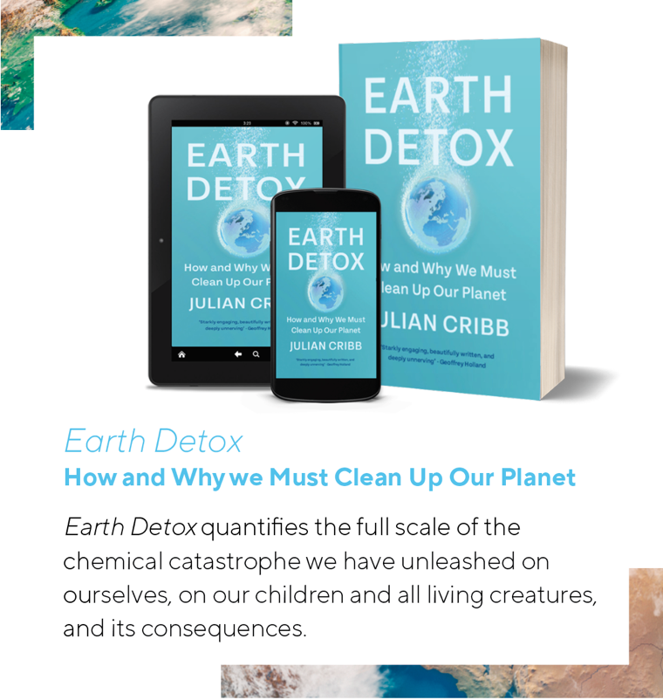

ARTS AND CULTURE

Dive into Perth Festival
Audiences will be swept along by currents of inspiration and waves of delight as the 70th Perth Festival celebrates the theme of Wardan (Ocean) this summer.
From great escapes in Fremantle and dancing on the sand at City Beach to oceanic orchestral concerts and a lighthouse dazzling young audiences at The University of Western Australia, the extensive 2022 Festival program is an open invitation to audiences.
“This 2022 Perth Festival program is designed to be as broad as the blue horizon and as cleansing as the sea,” says Artistic Director Iain Grandage (BMus ’94, DMus ’17). “I encourage you to dive in.”
The anarchic fun of Escape, a free multi-site family adventure inspired by the legendary 1876 Fenian convict getaway on the US vessel Catalpa, opens the Festival in Fremantle where the river meets the ocean with the promise of new horizons.
Escape celebrates Fremantle’s diverse voyages, cultures and stories. These encompass Noongar stories of departing spirits, tales of tall ships and the migratory waves since then. On February 11 and 12, visitors can see light installations, projections, music and other performances, share in a Mediterranean feast and revel in a re-enactment of the Catalpa escape – on bikes.
Ocean stories ground another free Festival event on the closing weekend when Noongar Wonderland transforms Perry Lakes into a world of storytelling and dance within an immersive light installation. Other Indigenous-led works include David Milroy’s musical Panawathi Girl and the play City of Gold by Meyne Wyatt, whose powerful anti-racism monologue was highlighted on Q+A in 2020.
The classical music program includes Emma Matthews performing beneath WA Museum Boorla Bardip’s famous blue whale and the WA Symphony and Youth orchestras join forces at Perth Concert Hall for John Luther Adams monumental Become Ocean and a new work by UWA-trained composer Olivia Davies.
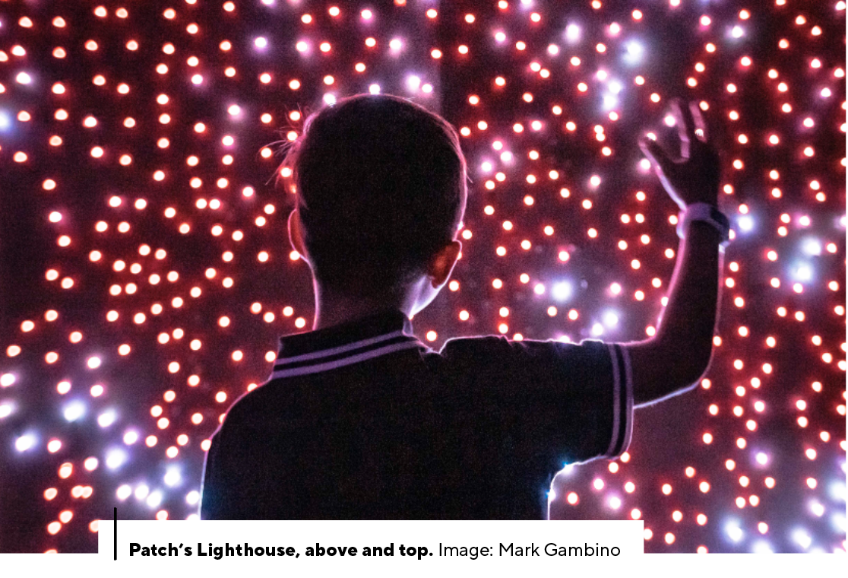
The UWA Crawley campus is already celebrating summer nights with the ever-popular Lotterywest Films in the beautiful “cathedral of pines” at the Somerville auditorium until April. UWA also hosts a major solo exhibition by Kimberley artist Sonia Kurrara at Lawrence Wilson Art Gallery and the sensational family event Patch’s Lighthouse, a journey of discovery through rooms beneath the UWA theatres, each full of hands-on explorations of light and its magical effects.
Playwright Kate Mulvany and actors Kate Walsh and Caroline Brazier combine for the landmark theatrical event Mary Stuart, while the dance work And the Earth Will Swallow Them Whole is set to absorb audiences at the State Theatre Centre and Ninth Wave will bring an apocalyptic dance party to City Beach.
A strong contemporary music program makes a welcome return for 2022, revealing new possibilities in unusual spaces across the city, including TA-KU’s wildly imaginative music and art installation chambers inside the old Karrakatta Club.
Perth Festival runs February 11–March 6. Lotterywest Films is running now at UWA Somerville until April 3. Full program and tickets at perthfestival.com.au

OUR GRADUATES

Seeking smart energy solutions
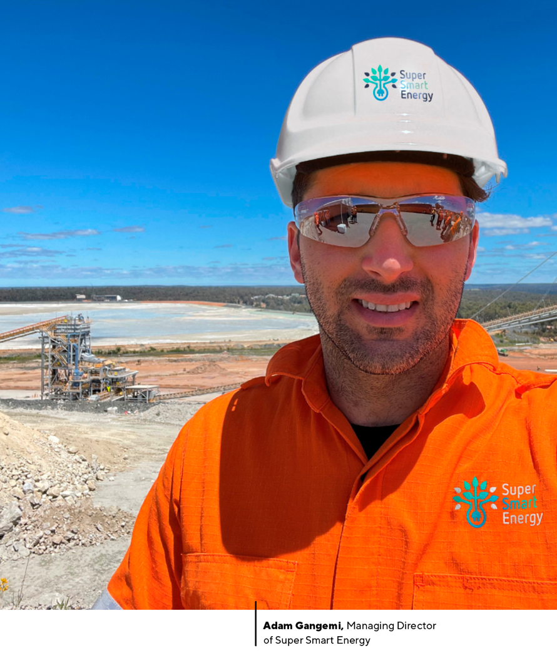

Adam Gangemi (MBA ’19) is among a new breed of young professionals committed to sustainable energy and carbon reduction solutions that will help decarbonise the Australian economy.
Mr Gangemi has worked extensively in the energy space, developing and managing energy reduction solutions for predominantly large-scale projects.
In 2018, driven by a desire to support Western Australian businesses to make compelling changes to their global footprint, Mr Gangemi founded energy advisory Super Smart Energy Pty Ltd.
As Managing Director of Super Smart Energy, Mr Gangemi leads the organisation’s commitment to enhancing environmental and economic outcomes through developing and implementing high quality, carefully considered and accessible decarbonisation strategies.
Mr Gangemi focuses on educating and enlightening clients about energy waste and working with them to implement evidence-based solutions that will deliver value including reducing carbon footprints and achieving savings.

How did studying an MBA help you launch your own company?
Coming from a technical background (geophysics), studying a business degree helped provide me with the business and financial skills needed to take the next step to manage my own business. It was never my intention from the start of my studies to go out on my own, however, with the learnings from the MBA and seeing others in the cohort achieve success in their own business I thought I could do it as well.

What does a typical day look like for you?
I am normally up at 5am to make my way into the office for a 6am start. These first few hours before people arrive and the phone starts ringing are so valuable to help set up the day and build movement. Once 9am arrives it’s normally internal meetings followed by project work or meetings with current and prospective clients. The afternoon is normally focused on reviewing current timeframes, proposed client strategies and technical challenges before making sure I’m home for bath time with my little one.

Why such a passion for renewable energy?
I used to work in the oil and gas industry and we were often shown the Macondo disaster in the Gulf of Mexico as an event we needed to avoid as a company. There’s an image of a pelican covered in oil from that spill which resonated with me. I often wondered about the way we could avoid such disasters and the serious clean-up costs. Then, as renewables began to build momentum and move to cost parity, the decision to make a career change was very easy as it made sense financially, socially and because of the impact it would have on the environment.

What carbon targets would you like to see in place for WA and Australia?
A zero carbon economy by 2040 and carbon offsets to be phased out by 2030 (if not earlier). It's ambitious, however, it's better to be bold and brave.

What are the biggest barriers to Western Australia switching to fully renewable energy?
Policy support and grid enablement for me are the two biggest barriers holding Western Australia back. If we had a government that supported the energy transition and made it easier for companies to add new projects either via infrastructure upgrades or renewable energy zones that would be a great start. Also, with the intermittent nature of renewable energy, making sure we have grid infrastructure that ensures continuous reliable power when the wind doesn’t blow or the sun doesn’t shine. This would require large batteries for instant power support and base load support that can support the grid for many hours.

What changes do you think we’ll see in the mining and energy sectors over the next decade?
Electrification, data and automation will be the big changes we see over the next decade. We are already seeing mining companies pushing for 60+ per cent renewable energy for new mining projects and insights from big data are helping the industry to improve productivity, communication and reliability. Automation will continue to improve and make mining safer by removing operators from site. Exciting times ahead!

UWA SPOTLIGHT

Global health: addressing social inequity
Social epidemiologist Professor Linda Slack-Smith (BSc ’83, PhD ’00) offers her perspective on global health, COVID-19 pandemic and mRNA technology.
A recent rather devastating Lancet editorial: The ethical darkness of global health drew on a Fulbright Lecture by David Miliband. Mr Miliband noted that we live in an age of impunity – and he speaks of “doing nothing as the norm”. The lecture, and in turn the editorial, raised the issue of how globally we often do nothing about horrendous circumstances for people in distant countries.
Global health is not just an important aspect of public health – it is increasingly integral to public health (and public health is integral to global health). Globally, public health continues to face serious challenges with substantial inequities, exacerbated by the current pandemic. An important global threat is the Severe Acute Respiratory Syndrome Coronavirus (SARS-CoV-2) virus, the coronavirus causing COVID-19. Outcomes from the pandemic have been extremely poor in many countries, regions and marginalised groups.
Social epidemiology is focused on social factors in epidemiology and draws on many disciplines. Never has epidemiology been so important. However, it has been frustrating at times to observe what was happening and realise what might be looming. This includes missed opportunities for prevention and reduction of disease, particularly ‘wicked’ or seemingly intractable health challenges. Understanding the complexity of such challenges is necessary if solutions are to be found. Hence, when we consider the COVID-19 pandemic, it is important to value the technology providing vaccine options while also recognising the challenges of using vaccines and public health measures optimally with substantial global inequity including poor housing, insecure work and food insecurity.
I was fortunate to be the co-chair (along with Professor Tony LaMontagne from Deakin University) of the World Congress of Epidemiology held virtually in September this year – what an amazing time to co-chair such a congress. The conference bought together epidemiologists from around the world, working in many areas of epidemiology and it was an inspiring and humbling experience to be involved. Being online allowed engagement from many people internationally who may not have been able to attend such a conference face-to-face. There was discussion at the conference of many areas of epidemiology – despite the pandemic there are many other health issues of importance in the program. Of course, many aspects of the COVID-19 pandemic were discussed – genome sequencing, wastewater surveillance, data linkage, modelling, vaccines and communication of science. In fact, ensuring messaging in the community was evidence-based and appropriate was a major concern raised during the conference. Many approaches to COVID-19 have been developed or further developed during the pandemic. While there has been a focus on vaccines, many aspects of public health play an important role.
Epidemiologists increasingly need to work with multidisciplinary teams. Often students come into our public health courses almost apologising for having a laboratory science background, but their interdisciplinary perspective is so valuable in public health and epidemiology.
As a social epidemiologist, I am particularly concerned about equity and social justice. We could have a very simple view where everyone is equally vulnerable to an infectious disease and the simple answer for everyone is getting vaccinated. However, it is so much more complex than that. We need to consider the impact of infectious disease and accessibility of vaccines for marginalised groups. We may have 90 per cent vaccination of adults in the population but a group of teenagers with a disability could still have no vaccine and be extremely vulnerable.
Vaccines, including the new mRNA vaccines, have helped to reduce spread, severity of illness and death in the community during the pandemic.
But while the array of vaccines, including mRNA vaccines used in the COVID-19 pandemic are new in terms of use, vaccine development has been occurring for decades. Accelerating the technology bodes well for vaccine development in the future and mRNA vaccines offer a safe, alternative type of vaccine.
The importance of ongoing research in relevant areas – both the social aspects of epidemiology and technological aspects of vaccines cannot be over-emphasised. Medical science and public health require strong collaborations and universities need to be supported to prosper and support such work.

NEWSMAKER

Chipping away at plastic pollution

Husband and wife team, Jordy and Julia Kay (BEnvDes ’14, MArch ’16), are stretching the packaging market in a new direction in the hope of putting an end to single-use plastics.
Ms Kay, who has a master’s degree in Architecture and a bachelor’s degree in Environmental Design from The University of Western Australia, and her winemaker husband created Great Wrap – the only Australian-made, home-compostable stretch wrap.
It was while she was working as an architect that Ms Kay reached a tipping point and decided she had to do something to reduce plastic waste.
“I had spent a lot of time choosing the right timber and understanding where it was coming from and making sure it was grown sustainably,” she explains.
“I was onsite when it arrived and it was wrapped in a petroleum-based pallet wrap. I was like ‘what is the point of all of that time if we’re still not thinking about the supply change and attacking those problems?’”
Ms Kay says her time at UWA gave her an awareness of materials and how they are made as well as giving her the ability to find solutions that are feasible in the real world.
These skills were harnessed to produce plastic and catering wraps that are broken down into carbon and water in 180 days.
“Everyone in big business is really excited,” she says. “This product has been a pain point in their supply chain for years and there is really nothing on the market that has been able to help them tackle the problem - we’re not really struggling
to sell it which is a great problem to have.”
To create the products, Great Wrap works with a company in Idaho that takes waste from making potato chips and turn it into a biopolymer.
Great Wrap is also looking to expand into food packaging in the next year which means moving from their current solar-powered facility, which is part of a food hub in Mornington, to a second factory in Tullamarine.
“We’ve just found that there is a lot of local potato waste in Melbourne that we’re able to get,” she says.
“We’re trying to lower our carbon footprint and there’s about 40,000 tonnes close to our next factory … tell everyone to eat more chips.”

CONVOCATION OF UWA GRADUATES

From the Warden of Convocation
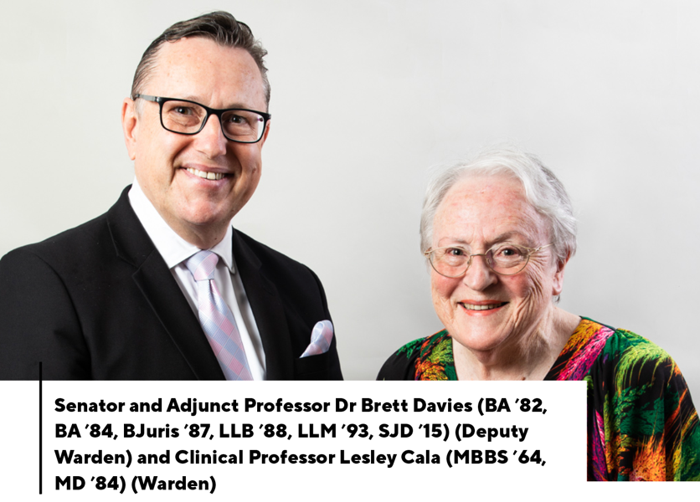

The Convocation of UWA Graduates continues to represent UWA graduates and provide them with an opportunity to engage in life at the University, and to participate in mentorship, research collaboration and professional networking. In the latest Convocation meeting, which was held in September, graduates from 16 countries joined via Zoom to hear live from the Vice-Chancellor Professor Amit Chakma and Guild President Emma Mezger on the issues impacting graduates and the UWA community.
There will be further opportunity to engage with UWA at the autumn meeting on 18 March 2022, which we hope will be a hybrid Zoom and in-person event.
The Convocation Council has been active in the past few months, reviewing its strategic priorities, including any changes that may require amendment to the UWA Statute. We are pleased to have been able to hold Council Meetings in person and via Zoom, and this has been welcomed by Councillors, greatly adding to the collegiate atmosphere.
Graduands at the December 2021 Graduation Ceremonies were welcomed as new members of Convocation by the Warden, Deputy Warden and three Councillors (Mr Jeff Gunningham, Dr Angela Evangelinou-Yiannakis and Cr Julie Matheson).
Convocation members, including all new graduates, are invited to vote for one Member of Senate (three-year term), the Warden and Deputy Warden (one-year term), six Members of Council for three-year terms and one Member for a two-year term. If you haven’t already, please update your details and register to vote online at convocation.uwa.edu.au.
Don’t forget to have your say in the 2022 Convocation elections!

Convocation Awards

Convocation Postgraduate Research Travel Awards
We received fewer applications in 2021 due to uncertainty about ongoing travel restrictions, but it is hoped the situation will improve for the 2022 awards.
Applications may be made online at convocation.uwa.edu.au

Bryant Stokes Matilda Award for Cultural Excellence
The winner of the 2021 award was James Dingley in the category of Drama for producing educational documentaries featuring UWA research, Australian culture, and key engineering concepts.
His YouTube channel ‘Atomic Frontier’ grew to 17 episodes featuring Rottnest Island’s Renewable Energy Grid, Esperance’s Pink Lake, Carnarvon’s NASA Tracking Station, and Australia’s Cold War Submarines. They have been viewed by people from 133 countries, allowing James to share cultural and scientific insights of Australia with the world.
Mr Dingley has recently commenced study at the Massachusetts Institute of Technology on a Fulbright Scholarship, so the prize was accepted on his behalf by his cameraman, Gus O’Neill.

Key Dates for 2022
Close of Poll for Convocation Election 8 March
Please take the time to vote online if you haven’t already!
Autumn Ordinary Meeting 18 March
Find out the results of the election and hear the latest news from UWA, with an opportunity to ask questions of the Vice-Chancellor and the Guild President.
Spring Ordinary Meeting 16 September
For details of elections and upcoming events convocation.uwa.edu.au

COMMUNITY IMPACT

A wealth of support for Australian-first student wellbeing hub
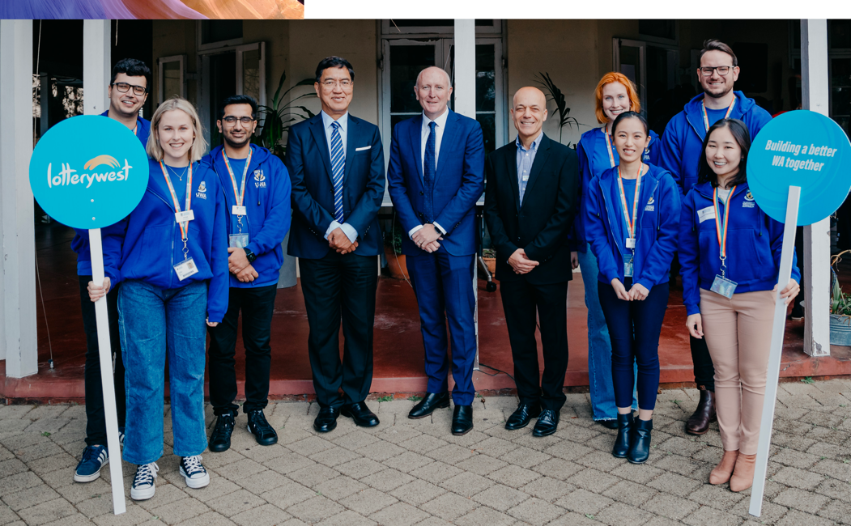

There are few moments more inspiring than a community act of collective generosity and kindness to support those affected by crisis. In the past 18 months, our UWA community has come together to support The Living Room – a unique on-campus student health and wellbeing ‘safe space’ that provides low barrier, peer-to-peer support for students who are struggling with their mental health.
With one in five Australian adults suffering from mental health issues each year, driven by external stressors such as the COVID-19 pandemic and uncertainty about the future, such support is increasingly in demand. The transition to higher education – a time of sharp emotional, social and academic adjustment that coincides with the peak age of onset for mental health problems – can leave many students requiring professional support. Unfortunately, many students do not seek professional help, or face significant barriers, leaving at-risk students without access to timely and effective support.
The Living Room responds directly to this need and is believed to be the first initiative of its kind on a university campus in Australia. The service is managed by mental health professionals and staffed by student peer supporters, who provide a range of services from emergency response for severe psychological distress to weekly wellbeing activities for students, such as yoga, mindfulness and ‘Pause with Paws’.
In its first 12 months, The Living Room has helped shift the thinking and acceptance of seeking mental health support within the student body. The ongoing conversation between students, UWA staff and The Living Room team has enabled data, experience and feedback to inform the service, allowing it to adapt and respond to student needs.
UWA Student Guild President Emma Mezger said The Living Room had proved immensely popular with students in its first year, with the team of student peer supporters providing a warm and welcoming environment for all students and helping to cultivate a sense of belonging and wellbeing on campus.
“The Living Room provides a low-barrier and easily accessible early-intervention service to students who are looking for support,” Ms Mezger said. “Its tranquil, yet easy to find, location in Shenton House allows students to walk in and be supported or directed to other services on campus.”
A unique aspect of The Living Room is the peer support team, whose members come from a range of disciplines and are able to consolidate their coursework with authentic, experiential learning. As part of The Living Room team they develop key skills, confidence and professionalism for future career development, while also supporting their student peers.
The UWA community response to The Living Room has been overwhelmingly positive and has sparked interest locally and internationally, with other universities exploring how they might replicate the service on their own campuses. Support for The Living Room has come from many quarters, including the inaugural Chair of Young Lives Matter at UWA, Mr Ronald Woss AM who campaigned tirelessly for its founding; the generous financial support of Dr Tony Howarth AO CitWA and Mrs Sally Howarth; the collective generosity of the alumni community locally and overseas; and student fundraising groups on campus. The Living Room has also received Lotterywest funding and formal recognition from Mental Health Minister, Hon. Stephen Dawson MLC, ensuring its future is secure as part of UWA’s ongoing student services.
The Living Room peer supporter Sophia Moore said. “We provide students with a safe, inclusive and calm space where they can have a supportive chat with a Peer Supporter, take part in wellness activities or take a moment to relax and unwind after a busy day of classes. Working as peers allows us to authentically engage with students, driven by our understanding of the student experience.”
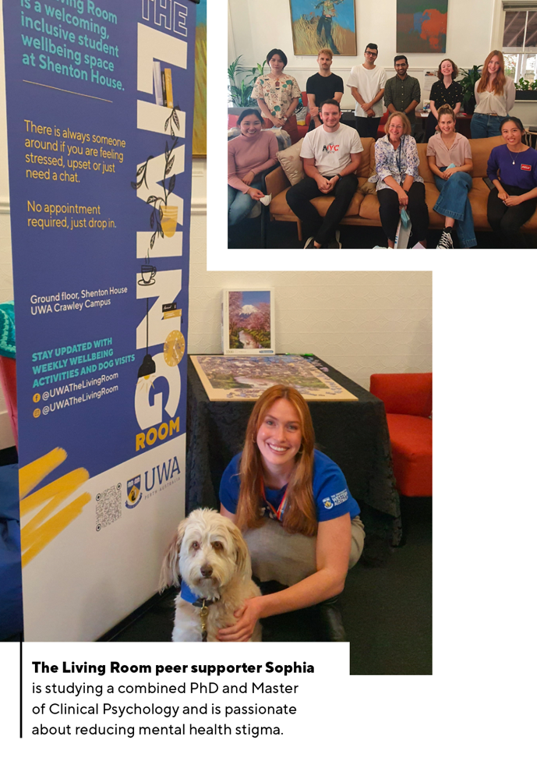

FLASHBACK

Discovery, Debate, Duty and Passion: 1968 Student ‘Peace Marches’
By Karen J Worrall (BA ’80)

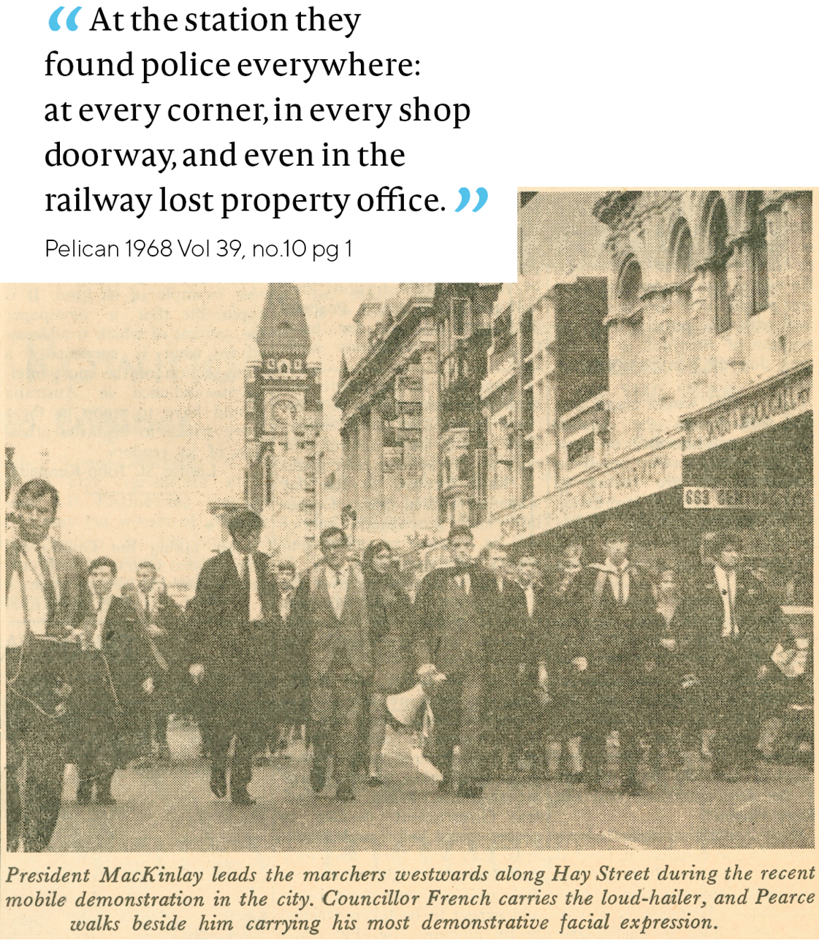
A deep dive into the archives of the Pelican student guild publication reveals that, among the ‘halcyon days’ of new social freedoms, newfound prosperity and global recognition, Western Australia in the late 1960s was also a place of polarised emotions. This was driven in part by Australia’s increasing, and for many, unpopular involvement in the Vietnam War, coupled with the introduction of two-years national service by a randomly selected ‘birthday ballot.’
Telling times indeed, with the August 1968 edition of Pelican’s spirited reporting on ‘Peace Marches’ led by fully-gowned students — most notably then Guild President David MacKinlay and current UWA Chancellor The Honourable Robert French AC CitWA (complete with megaphone) — silently marching along St Georges Terrace. What stands out is the publication’s thoughtful reflection and respect for both sides of the ‘march for peace’ debate.
Unlike less peaceful student demonstrations that erupted globally in the mid-60s (as pictured in the June 1966 Pelican above), no one was arrested, and no draft cards were burned. It is proof, if proof is needed, of the shared values across the decades, that continue today: Freedom to engage in open exchange in times of change and the fostering of tolerance and resilience.
“It was a privilege for me to lead the strong Guild contingent into the City in support of an issue important to the Nation — and to me personally. I had not bought into the then prevalent ‘domino theory’ (if Vietnam was to fall to Communism, Australia would soon be under threat) and I was troubled by Australia supporting a US intervention into the affairs of a sovereign nation. It was pleasing that the protest was both dignified and emphatic. The focus was on the issue of peace and not the behaviour of students, as was the case with other protests. It also opened the way for more active student participation in public affairs for the future.”
– Dr David MacKinlay (BE ‘69, BCom ‘73, DCom ‘14)
You can read Karen J Worrall’s full article The decade that was the making of us: A look back at 1960s, along with original pages from Pelican (Vol.39, No.10, 1 August 1968) at uwa.edu.au/news/topics/uniview
Images courtesy of UWA Student Guild Archive.

Can you help?
The UWA Historical Society (UWAHS) has launched a project to record and document UWA staff, students, and graduates who served in the Australian Defence Forces during the Vietnam War era. If you have any information regarding your own service, or that of a friend or family member, let us know at ircohe.net/Vietnam.
UWAHS encourages appreciation of, and fellowship of persons interested in, the history of the University. Membership and further information is available at bit.ly/UWAHS.

COMMUNITY UPDATE

Mary’s Tree
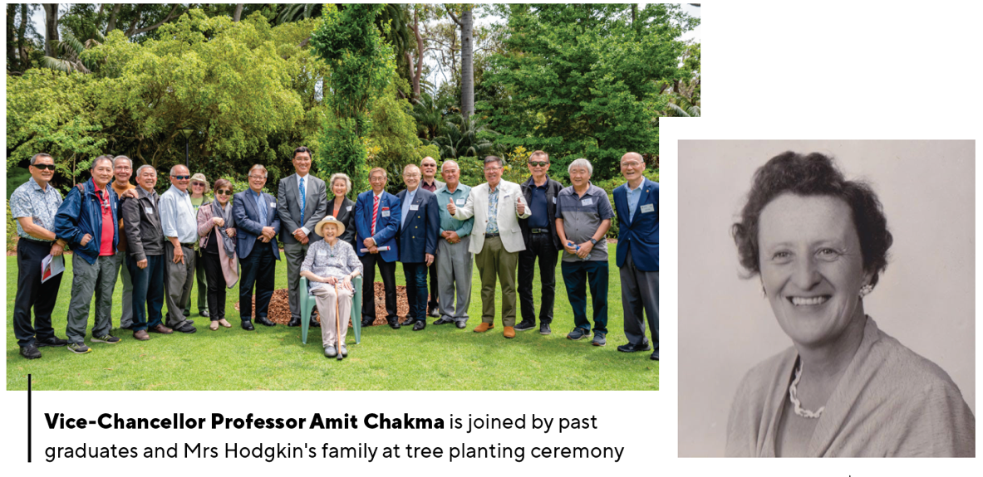
Anthropologist, lecturer, student advisor and graduate, Mary Constance Hodgkin OBE (BA ’59, MA ’62) (1909-1985) was remembered in November for her invaluable contribution and dedication to the welfare of students from Singapore and Malaysia studying in WA during the 1960s and 1970s. Current students from Singapore and Malaysia and members of Mrs Hodgkin’s family joined Vice-Chancellor Professor Amit Chakma and the graduates from 50 years ago – for whom Mrs Hodgkin provided generous hospitality, practical help and much needed emotional support – for the touching ceremony and planting of a native tree from Singapore near the Tropical Grove.

Stop the Clock
By Adjunct Professor Warren Kerr AM (BArch ’74)

As many astute members of the UWA community have noted, the much-loved clock that graces the Winthrop Hall tower stopped some time ago. It may surprise you to learn that this iconic symbol of UWA has become a casualty of the COVID-19 pandemic.
This precautionary measure was taken following an inspection of its internal workings, which revealed that cogs vital to its operation had become very worn, affecting its ability to maintain accurate time.
Because its historic mechanism is also linked to surprisingly modern satellite technology, it requires a clock repairer with a specific set of skills to undertake the repairs. However, the only person known to possess this skillset is based in Sydney and, as such, is unable to travel to Perth to undertake the repairs due to border restrictions.
As a result, it may be some time before the Winthrop tower clock is again operating and reliably telling the time to campus visitors and Stirling Highway travellers.
If any member of the UWA community can help us locate a specialist clock repairer in Western Australia with the skills required to repair this unique clock, get in touch at convocation@uwa.edu.au

Introducing Alumni Mentor Link
A new online graduate-to-graduate mentoring program, providing unprecedented access to build UWA career connections locally and globally, will be available from UWA in early 2022. Alumni Mentor Link connects recent graduates with mid-late career graduates from a variety of professions and workplaces – no matter where they are in the world – for meaningful conversation across any career development topics and mentoring needs. Keep an eye out in the new year for more information on how you can be part of this mentoring program.

