EOI Artwork Commission Application
A collaborative project for Lawrence Wilson Art Gallery, CSIRO Environment at IOMRC and School of Design, UWA.
Page 1

Closing date for submissions: Extended to Friday 5 April 2024
EXHIBITION INFORMATION AND SELECTION CRITERIA
Artists are invited to submit an Expression of Interest for an artwork commission to be exhibited at the Lawrence Wilson Art Gallery in the Schenberg Study Centre for a period of four weeks in July/August 2024. A budget of $5,000 has been allocated for the total cost of this commission including artist fees and material costs. Installation, promotional and signage costs will be met by the Gallery. We seek proposals from experienced and emerging professional artists for production of a solo or collaborative artwork that may be produced in a variety of media.

The successful Artist must be able to respond to the Artist Brief and operate independently with limited assistance from the Curator of Public and Academic Programs and LWAG installation officers and attend a minimum of three progress meetings.

Applications from collaborative groups of two or more artists should submit one joint proposal.

Artist/s are expected to assist and participate in related public and education programs, such as an artist talk in the exhibition during the period it is on display. The fee for this, and production of an associated Artist Statement are included in the Commissioning fee.

The successful Artist/s MUST be contactable during normal office hours in the three weeks prior to the exhibition and during the period of installation. It is expected that the
Artist/s will be on site to assist with the exhibition installation.
Selection Criteria:
Candidates must be able to satisfy the following to apply:
Be a practicing Artist/s based in WA
Candidates who have demonstrated experience in previous artwork commissions, either individually or as part of a team, will be highly considered.
Selection
The artwork commission application will be reviewed by the Project Partners and selection will be made by a panel including:
CSIRO Environment at IOMRC: Dr Fabio Boschetti and Dr Matthew Andreotta
LWAG: Dr Janice Lally and Anthony Kelly
School of Design, UWA: Sarah Douglas
Selection Confirmed by: Extended to 12 April 2024
Contract Signed by: Extended to 19 April 2024

PERSONAL DETAILS
Name:
Email:
Address:
Phone: |  | Mobile:

Expression of Interest/Proposal

PROPOSED ARTWORK OVERVIEW
Provide a description/ statement of intent:
Why are you interested in this commission?
How is the proposed commission relevant to your own practice?
What are your initial thoughts?
Provide a brief indication of your conceptual approach to this brief.
Provide a summary of the indicative proposed Artwork content (materials and scale).
Please include this information (500 words Maximum) together with the Artist(s), CV, biography
in a single pdf file and provide this as part of your Application, together with a separate pdf with images as follows:
Image pdf:
Please provide images of your work: no more than 10 images of relevant past work, together
with a related list of information: Title, (year), materials, size (h x w x d cm).
Please give a basic breakdown of how you would allocate your budget in the table below.

Total budget: $5,000

Artist fee $
Artwork production/ materials costs $
Hire of any specific technical requirements (not available from LWAG) $
Special installation requirements/ costs, (not available ‘in kind’ from LWAG) $

TOTAL EXPENDITURE $
The Artist Brief
The artwork is intended to be the result of the artist’s own ideas, investigation and learning, together with their personal response to marine and ocean research data and issues relating to concerns for the ocean and its future.
The process of development and delivery of the project is intended to be enjoyable and collaborative:
During the development period, the artist will be required to undertake an intensive, but brief ‘artist in residence’ experience by arrangement, with scientists from Commonwealth Scientific and Industrial Research Organisation (CSIRO) Environment at the Indian Ocean Marine Research Centre (IOMRC); for example, involving meetings with and observation of work by key staff at the centre.
Refer to Attachment 1 for Campus Partner details and to see indicative CSIRO research refer to:
http://www.per.marine.csiro.au/staff/Fabio.Boschetti/
https://matt-lab.github.io/.
https://people.csiro.au/B/C/Cindy-Bessey
The artwork can be of any material or in any form that can be accommodated within the scale and scope of the exhibition space including technical requirements (details to be negotiated and confirmed with LWAG partners), for display in the ‘Schenberg Room’ within the Lawrence Wilson Art Gallery (Refer to Attachment 2 for details).
Depending upon the proposed materials and form, consultation with and use of UWA School of Design facilities and equipment may be arranged.
- Target audiences and engagement strategies/public and education programs:
- Target audiences include but are not limited to: CSIRO Environment at the Indian Ocean Marine Research Centre and IOMRC professionals, all UWA academic staff and students, public and private school, and college students (primary, secondary, and tertiary), and the general public.
- The exhibition will include an opening event – this will be organised and paid for by LWAG.
- Intent: This artwork will contribute to the educational component for a collaborative art and science project for school students, (see Attachment 3) from three partner schools who will specifically visit the LWAG to view this work/s in the July – August period - 15/7/2024 -15 /8/2024
- School tours will be promoted and scheduled to visit the exhibited artwork. The artist will be required to be present for informal discussion with booked school visitors on two occasions of 60 minutes apiece.
- During the period of the exhibition of this artwork, an artist talk /panel discussion for the public and School Students will be held at LWAG in partnership with CSIRO + the Artist/s + other professionals 22 or 23/7 /2024 OR 29 or 30/7/2024 (details and date to be confirmed).
- The commission process will be documented in consultation with the Project Partners and the Artist/s in the form of brief video clips that may be posted on the LWAG and Partner websites.
- Promotion of the exhibition and all public events (invitations and hospitality), will be covered by LWAG and will include: LWAG website, e- newsletter, Instagram.
- Signage will include a Title wall sign, didactic wall panel and artwork captions and a printed Artist Statement room sheet, which will be available in the exhibition.
Research Content
Artist in Residence experience involving conversations and observations with scientists from CSIRO Environment at the Indian Ocean Marine Research Centre.
The artist will be required to meet with and be in communication with the Project Partners (refer to Attachment 1) that include:
- Research scientists from the CSIRO Environment at the Indian Ocean Marine Research Centre based at UWA. These include: Dr Fabio Boschetti, Dr Matthew Andreotta and Dr Cindy Bessey
- Professional staff at the Lawrence Wilson Art Gallery, UWA. These include Curator of Academic and Public Programs, Dr Janice Lally and Collections and Exhibition Officer, Anthony Kelly.
- UWA School of Design Lecturer and Curator Fine Arts, Sarah Douglas
Additional consultation and support will be freely available throughout the commission process with the Artist/s being welcome to interact with and seek input from the Project Partners and with the Partners viewing work in progress by arrangement with the Artist/s, such as with studio visits or specific site meetings.
Schedule
Progress meetings will be required: a start-up meeting, a stage one concept meeting and progress meetings during the development, production and prior to installation. (Refer to Attachment 4– The Ocean Project Schedule).
Artwork parameters
The artwork will be of a scale and using materials, and with any required associated AV and technical equipment (eg video screens) that is suitable to be installed in the Schenberg Study Centre in the LWAG, and to be viewed safely by the public.
LAYOUT PLAN & DIMENSIONS supplied (Refer to Attachment 2).
TECHNICAL AV options available include some video screens.
SCHOOL OF DESIGN resource facilities and equipment may be accessed by arrangement.
Some plinths and cases are available for this exhibition.
Note: Insurance of the work/s is covered by LWAG

Please complete the application form details and attach your resume with supporting material as two pdfs (text and images -with a list of their details)
Email to: janice.lally@uwa.edu.au

If you have any questions pleased contact:
Dr Janice Lally, Curator (Public and Academic Programs), Lawrence Wilson Art Gallery, The University of Western Australia EMAIL: janice.lally@uwa.edu.au

BACKGROUND INFORMATION

LAWRENCE WILSON ART GALLERY

The Lawrence Wilson Art Gallery (LWAG) is a university art gallery of international standing that plays a pivotal role in supporting the educational, research, and community engagement efforts of the University of Western Australia. LWAG are stewards of two significant art collections: the University of Western Australia Art Collection and the Cruthers Collection of Women's Art. The gallery is well known for championing contemporary art and emerging artists, and showcasing the diversity of Western Australian art.

The LWAG team is responsible for the curation and management of evolving nationally significant art collections. We present an annual program of intellectually rigorous and engaging exhibitions that contribute to the local and national arts landscapes. These exhibitions are accompanied by curated public programs that promote critical debate along with a series of engaging events designed for diverse audiences and communities.

An accompanying academic program extends the role of the gallery, initiating campus and community partnerships that include collaborations for object and experiential learning for tertiary, secondary and primary level students and contributing to research and the development of new academic curricula, projects and conferences.

As a centre for artistic exploration, LWAG benefits students and faculty, fostering creativity and intellectual growth. Beyond the University, LWAG reaches out to the public, offering lectures, workshops, and other initiatives to enhance appreciation and understanding of art and culture.

UWA Art Collection
The UWA Art Collection is one of Western Australia’s most significant collection of Australian art.
The collection began with the acquisition of books and art works by Professor Walter Murdoch while on a trip to Europe in 1927, with funds provided by the Hackett Bequest. The purchase of artworks began in earnest in the early 1950s with funds from a number of generous bequests, including The Tom Collins Memorial Fund. This fund enabled the purchase of nine important paintings by Sidney Nolan from the late 1940s, with Australian modernism remaining a major strength of the collection.

The collection expanded significantly between 1980 and 1995 with the generous Skinner Bequest, and with an acquisition focus predominantly on living Western Australian artists. It also includes major works from Australia’s leading contemporary artists, including Simryn Gill, Imants Tillers, Jenny Watson and Susan Norrie.

CCWA
The Cruthers Collection of Women’s Art (CCWA) is Australia’s largest public collection of women’s art. The Collection is founded upon a substantial gift made by Sir James and Lady Sheila Cruthers to The University of Western Australia in 2007. Sheila Cruthers and her son, John, began collecting women’s art in the 1970s, focusing on portraiture and self-portraiture. It is an eclectic collection, spanning works from the 1890s to the present day. The University continues to develop the collection to reflect contemporary women’s art practice as well as making visible lesser-known artists from the past.
The CCWA includes well-known historical figures such as Clarice Beckett, Elise Blumann and Clara Southern; contemporary artists including Penny Bovell, Destiny Deacon, Sarah Contos, Rosella Namok and Sangeeta Sandrasegar; and lesser-known artists including Stella Dilger, Leanne Emmitt and Lola Ryan.
The mission of the Cruthers Collection of Women’s Art (CCWA) at The University of Western Australia is to promote women and non-binary artists by way of exhibition, research, teaching, publication, and acquisition, as an alternative reading of Australian art history.

Current and previous exhibition information can be found on the gallery website https://www.google.com/search?q=lawrence+wilson+art+gallery&sourceid=chrome&ie=UTF-8

CSIRO ENVIRONMENT at IOMRC

CSIRO’s Environment Business Unit brings together capabilities in marine, atmospheric, water and terrestrial environment disciplines, as well as significant social and economic research, to align and support the nation in creating a better and more sustainable future.
Research examines the increasing pressures facing our natural and built environments from the combined effects of climate change, extreme events, non-sustainable use of natural resources and legacy activities.
Additional collaboration includes experts from across CSIRO. These include National Collections & Marine Infrastructure, Health & Biosecurity, Agriculture & Food , Data61, other Business Units and Enterprise Services across CSIRO, and other publicly funded research agencies, the universities , industry and communities to deliver impactful science.
Australia’s biggest environment challenges are addressed by translating complex science into decision ready information and tools essential for sustainable and equitable economic, social, and environmental management and development into the future.
UNITED NATIONS DECADE OF THE OCEAN
https://projects.noc.ac.uk/iwg/decade-undos
https://news.un.org/pages/lungs-of-our-planet/

ATTACHMENT 1

THE OCEAN PROJECT 2024 - CAMPUS PARTNERS

COMMONWEALTH SCIENTIFIC AND INDUSTRIAL ORGANISATION (CSIRO) ENVIRONMENT at INDIAN OCEAN MARINE RESEARCH CENTRE (IOMRC)

Fabio Boschetti

Summary: I am an applied mathematician with a strong multidisciplinary experience, ranging from numerical optimisation to complex system science, modelling of ecological, socio-economic and geophysical processes, information theory and statistical analysis, among others.
My work is currently applied to the management of natural resources and their interaction with human activities.
Current Research. I try to improve our understanding of how we can best model ecosystems and their interaction with human activities and how to communicate the results. We know that ecological and human systems are 'complex‘.
From the one hand, we need to address this complexity, accounting for multiple phenomena interacting at different scales, uncertainty, many degrees of freedom and feedback cycles messing up causal relations. From the other hand, we need to simplify our analysis to make it manageable.
Finding some sort of workable compromise is what most of my research is about. Publications. I have published 100+ refereed publications, including 70+ fully-refereed journal papers and book chapters, in disciplines as diverse as numerical optimisation, philosophy of science, complex system science, environmental science and theoretical biology.
A full list of papers together with the electronic copies of most of my publications is available at http://www.per.marine.csiro.au/staff/Fabio.Boschetti/

Matthew Andreotta

Summary: I am a social and cognitive psychologist interested in belief formation and change. I blend psychology with data science techniques to identify meaningful patterns in social media data that reflect public perceptions and opinions. I have applied my methods to pressing societal issues, such as climate change, the influence of misinformation, and detection of research with misconduct or integrity concerns. More broadly, I aim to make science more accessible to scientists and the public alike. A more comprehensive account of my history can be found in my academic curriculum vitae: https://matt-lab.github.io/assets/cv/cv.pdf
I hold a postdoctoral fellowship at the Commonwealth Scientific and Industrial Research Organisation (CSIRO). The aim of my current research is to develop semi-automated approaches to monitor social acceptance and social change concerning the marine environment. Building on social psychology theory and current advances in Big Data, I aim to pre-empt conflict and identify the antecedents of public support. research website: https://matt-lab.github.io/.
I am open to collaborations, invitations for guest lectures, co-supervision of students, and projects that increase the accessibility of science. If you are interested in working with me, please reach out.
Cindy Bessey

Summary: Dr Cindy Bessey is a marine ecologist whose passion is understanding the role of lower trophic level organisms in sustaining diverse, productive and healthy ecosystems. Cindy’s research projects have included investigating trophic interactions in threatened seagrass ecosystems, evaluating how commercially important fish populations are affected by varying environmental conditions, and assessing the risk that genetically modified fish pose to the natural environment. She currently manages the Ecological Genetics laboratory and works on advancing environmental DNA (eDNA) techniques for successful implementation into bio-monitoring programs which are cost-effective, easily deployed and accessible to anyone. Her focus is on obtaining diversity data in coastal and offshore systems in order to evaluate ecosystem changes resulting from both anthropogenic and natural pressures. Her international employment experience includes positions with the Western Australian Department of Biodiversity Conservation and Attractions, the National Oceanic and Atmospheric Administration in California, USA, and the Department of Fisheries and Oceans in British Columbia, Canada. https://people.csiro.au/B/C/Cindy-Bessey

Janice Lally
Summary: Dr Janice Lally is Curator of Academic and Public Programs at Lawrence Wilson Art Gallery at UWA. Following her research career in medical science (including clinical biochemistry, molecular biology and neuroscience in national institutions), she has been an art museum and gallery director, curator, arts manager and independent consultant and writer in the arts, crafts, design, and cultural heritage sectors nationally and internationally. She was awarded her PhD in the History and Philosophy of Science from the University of Melbourne in 2003. She has curated and managed numerous exhibitions and public and academic programs involving historical and ethnographic material, and contemporary art, craft and design, in public institutions including university art museums in Australia. She has overseen policy development in the cultural sector, and the commissioning of more than 100 public art projects nationally and internationally including in the MTR in Hong Kong. Her work contributes to cultural development and academic innovation together with educational outreach, with a current focus on linking art with science.
Anthony Kelly
Summary: Anthony Kelly has been Collections and Exhibitions Officer at Lawrence Wilson Art Gallery at UWA for over ten years. In this role he supports collections management and oversees the design and installation of exhibitions. These include 2D and 3D artworks and mixed media installations involving audio visual and light components. A visual arts graduate of Curtin University he has also been an exhibiting artist. He has previously supported the delivery and installation of a number of Campus and Community Partnership art and science projects at LWAG.
SCHOOL OF DESIGN
Sarah Douglas
Fine Arts Major Coordinator
Curator
UWA School of Design • M433, Perth WA 6009 Australia
Faculty of Arts, Business, Law and Education
+61 8 6488 1440 • 0400036816 • sarah.douglas@uwa.edu.au

ATTACHMENT 2

THE HAROLD SCHENBERG STUDY CENTRE- the ‘SCHENBRERG ROOM’ at LWAG
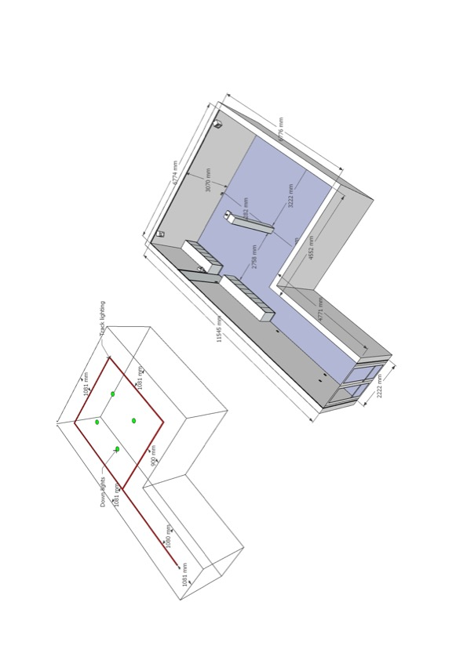

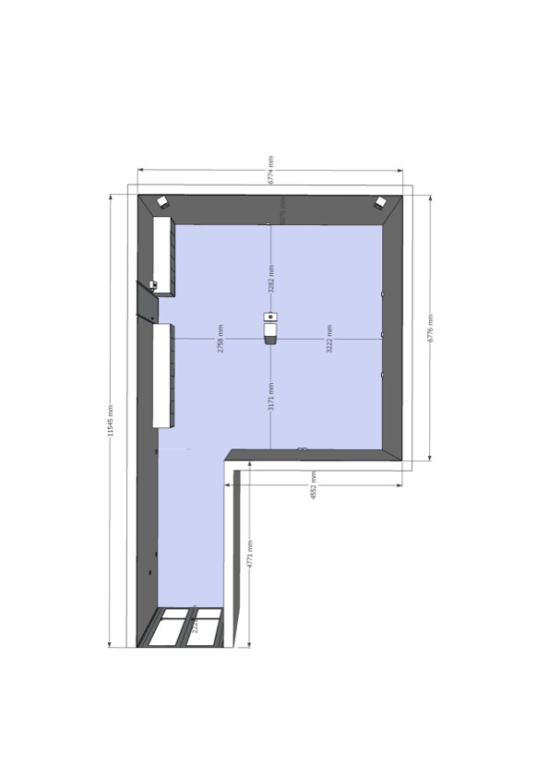

ATTACHMENT 3

SUMMARY- THE OCEAN PROJECT 2024 – AN ART & SCIENCE COLLABORATION

This is a project that links art with science for educational and public benefit outcomes.

Bringing ART together with STEM.

Objectives

Lawrence Wilson Art Gallery (LWAG) together with Campus Partners, the Commonwealth Scientific and Industrial Research Organisation (CSIRO) Environment at the Indian Ocean Marine Research Centre (IOMRC) and the School of Design, UWA, all located at the University of Western Australia have agreed to collaborate in a project that will address and link STEM topics together with visual art and literacy; for educational, social and cultural development benefits for UWA staff and students, the wider education sector, arts and scientific industry partners and the community.

To highlight the integral role and capacity of art in education and sharing knowledge.

To encourage students’ inspiration towards future careers and conceptual capacities.

To address key topical science and art themes.

The Themes
Science

The Ocean is a key arena for research in WA and globally.

This is relevant to schools and the public for a range of reasons – including biological, mathematical, social and cultural concerns and studies.

Currently there is a UN Decade of the Ocean focus in research.
Australia, together with Japan and the US, is a partner in producing a global scale survey about concerns for the future in relation to the ocean.

The CSIRO Environment at IOMRC has been researching Oceanography and Marine Biology in WA; in the field (eg 20 years of data collected at Ningaloo), with mathematical modelling (eg a projected future to 2050 in a Kimberly study) and with research in cognitive and social sciences relating to the Ocean You Want- for the UN Decade of the Ocean.

It compiles and analyses data on a multitude of vectors.

This has ramifications for diverse sectors- for example: the collection of reliable long range scientific data, and projecting environmental, social, cultural and economic impacts.

Art + Science + Culture

Visual artists have always embraced investigation and employment of new and emerging technologies and cross- disciplinary skills in the pursuit of communicating complex ideas, values and critical thinking.

For example, most recently, use of digital arts, computer science and animal communication; together with virtual reality, gaming technologies met with paint, ink, water and papier- mâché also speculative fiction, in the FAM+23 UWA Fine Arts + Electronic Music and Sound Design Graduate Exhibition.

LWAG has previously worked with Campus and Community Partners for Art & Science, engaging with related Indigenous cultural concerns in investigative projects that have been realised in exhibitions in the Schenberg Room at LWAG.

Examples have included: Art and Astronomy; (International Centre for Radio Astronomy (ICRAR). partner in 2019); A Natural Connection (STEM botanical theme, 2020) and the 2020 Schools project (relating to LWAG’s Feeling Abstract and the Berndt Museum’s Creatures exhibitions in 2020).

These projects involved schools from diverse demographic contexts and from urban, regional and remote locations.

Strategy for THE OCEAN PROJECT 2024

Art has a capacity to reveal, communicate and evoke complex information, emotions, images and ideas.

This will be investigated and demonstrated in a staged project: new artworks will be created that arise from informing and engaging artists (both professional artist/s and students) with scientific issues together with cultural concerns.

To provoke new ideas and engage and share skills with each other and to communicate to a wide audience, a diversity of the concerns and issues that have been researched by the artists in partnership with scientists and cultural leaders.

The project will explore and exhibit the capacity for collaboration across disciplines while investigating knowledge that is significant and topical – eg ocean science and new technologies, and Indigenous cultural knowledge, bringing new research and scholarship to a wider audience- especially to students at all levels.

Partnerships
CAMPUS: LWAG, CSIRO Environment at the Indian Ocean Marine Research Centre (IOMRC) and the School of Design, UWA - staff and students
COMMUNITY: Public Schools and Colleges- staff and students

The Stages – partners, activities, outcomes

The Challenge:

Public Lecture
The communication of complex ideas will be canvased and debated in a public lecture /or discussion at LWAG, for a wide public audience.
The theme for this would relate to the ocean: dealing with research data and modelling and evaluating projections for the future.
Campus Partner CSIRO Environment at IOMRC

Artist Talks: art and science in arts practice
Aspects of art and science in the creation of contemporary art will be discussed by graduate artists who are continuing their research and study at the School of Design in 2024.
This will be scheduled to suit visiting school students during Science week 10-18 August 2024. Campus Partner School of Design.

II
Artwork commission- emerging or mid-career artist/s

A practising artist will be offered the opportunity to be commissioned to produce an artwork that is informed by an Artist in Residence experience with CSIRO Environment at IOMRC along with their own research, to communicate and share the artist/s’ responses.

The artwork will be installed for public exhibition at LWAG- in the Schenberg study Centre during a period in July/ August 2024.

It will be available for inspiration and discussion with school students and the public through a public event during the exhibition period.
It will contribute to the partner school’s students’ inspiration together with their own workshops and input with CSIRO Environment at IOMRC partners to produce their own artworks for exhibition later in the year.

An Opening event will be held for the exhibition.

III
The Schools Project

Three partner schools - along with all other interested schools - will visit LWAG during the period of the Artist Commission exhibition in July/August 2024.

They will view the commissioned artwork and attend a public event for students, a conversation between the artist and two key CSIRO Environment at IOMRC partner scientists.

They will also visit / or experience some ‘hands on research’ aspects of CSIRO Environment at IOMRC (by arrangement - Details to Be Confirmed).

The schools will also be led by the CSIRO Environment at IOMRC scientists and guided by their teachers in responding to an extract of the UN’s Decade of the Ocean Global Survey about the future of the ocean.

They will do this in their classrooms and research and explore scientific and culturally related issues guided by their teachers and participate in cultural workshops with their own local Aboriginal Elders. They will prepare their own survey responses and related artworks for exhibition at LWAG for 2 weeks in November.

An Opening event will be held for the schools’ exhibition for both families and the wider public.

The Schedule Nov 2023- Nov 2024 key dates at LWAG
Public Lecture: March / April 2024
Artist Commission Exhibition + public event + school visits: July / August 2024
Science week events: 10-18 August 2024
Schools Exhibition: November 2024

ATTACHMENT 4

THE OCEAN PROJECT 2024 – ARTWORK COMMISSION SCHEDULE

Date | Action | Payment
5 April | EOI Application Submitted
12 April | Selection Confirmed
19 April | Contract signed, start-up meeting | 1st payment: $500
22 May | Meeting to view detailed concept and design and confirmation of second payment | 2nd payment: $1500
12 June | Meeting to view work in progress
10 July | Meeting to view completed work prior to installation
15 July | Installation commences | 3rd Payment: $2000
20 July | Opening event
15 August | Close of exhibition, de-installation commences | Final payment $1000

