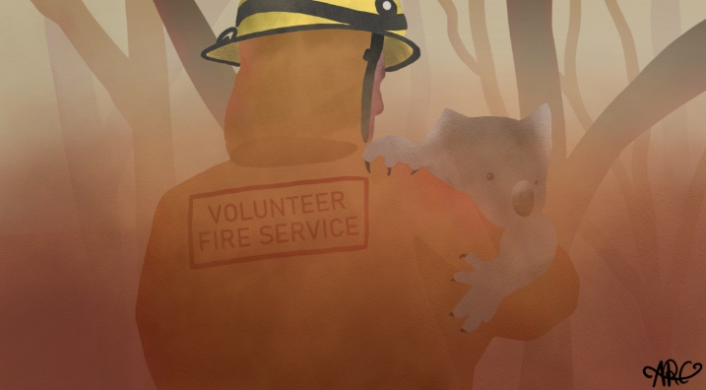
SUPPORTING THE ONGOING WELLBEING
AND RESILIENCE OF AUSTRALIA’S EMERGENCY SERVICES

FREQUENTLY ASKED QUESTIONS (FAQs) for participants
- What is the aim of the survey?
The aim of this voluntary survey is to understand how the experiences of emergency service personnel affect their wellbeing and resilience. This will enable us to understand the supports needed by those who may have been affected by the recent bushfires and how to foster resilience and effective coping strategies into the future.

- What is the survey about?
Following the devastating 2019-20 bushfire season, there is a critical need to monitor the associated impacts on volunteer and paid emergency service personnel. This means understanding more about their experiences during this time, regardless of whether they were directly involved in responding to the fires or whether they played supportive roles in the community or their organisation, as well as information about their mental health and wellbeing, and use of support services.

- How long does it take to complete the survey?
The online survey should take about 20–25 minutes to complete.

- Can I complete the survey on a mobile phone?
The survey can be completed on a mobile phone, however it is easier to see all the options on a tablet or desktop computer. If you do complete the survey on a mobile phone it may be necessary to scroll down to see all of the options.
- What input has the fire and emergency services sector had into the survey?
The survey was developed by the research team at The University of Western Australia, led by Associate Professor David Lawrence, with guidance from a Reference Group comprising senior leaders from emergency services agencies, agency representatives, fire and emergency services employees and volunteers, researchers with expertise in epidemiology, post-traumatic stress and workplace mental health, and expert practitioners.
- Who can take part in the survey?
A representative random sample of more than 5,000 employees and volunteers in fire and rescue and state emergency services agencies across Australia are being invited to participate in the survey. Participants have been selected at random and not on the basis of their wellbeing or their involvement in the 2019-20 bushfire season. This is to provide a representation of the needs of the whole emergency services sector.

- Will my answers remain confidential?
Yes, your survey results will remain completely confidential. No identifying information about you from the survey will be released to anyone. The survey software is provided by Roy Morgan Research and is completely independent of all emergency services agencies’ IT environments. The information you provide will be held securely and managed by Roy Morgan Research and The University of Western Australia. Your confidentiality is ensured by the ethics approval granted by the UWA Human Research Ethics Committee. All results from the survey will be released in combined form only.

Within the survey there is an option to provide your email address to be contacted for a follow up survey in 12 months’ time. Supplying your email address is completely voluntary. Your information will only be used by the research team in order to send the survey to you and will not be shared with your agency. If you do provide your email address it will be stored securely for 12 months and used to contact you again, after which time it will be deleted.
- Is the survey compulsory?
Participation in the survey is completely voluntary. You can withdraw from the survey at any time during completion. If you don’t feel comfortable providing an answer to any question, you don’t have to. However, to be able to produce a comprehensive picture of the mental health and wellbeing of emergency services personnel, we encourage you to participate fully in the survey.
- What if I don’t want to answer some of the questions?
Your participation in the survey is completely voluntary. If you choose to participate, we hope that you will answer all questions. If you can’t answer, or don’t feel comfortable answering, any question you don’t have to. You may withdraw from the survey at any time.
- I don’t work in an operational role – do I need to do the survey?
Yes, we are trying to capture a representative picture of all the people who work in emergency services agencies.
- What if I find some of the questions distressing?
The survey includes questions about issues that you may have experienced and services you may have used, which you may find distressing. If participating in the survey raises any concerns about how you have been feeling, and you would like to talk to someone, there are a number of support options available to assist you:
- You can visit your GP, another health professional, or contact your agency’s Employee Assistance Program.
- The beyondblue Support Service also provides free, immediate, short-term counselling advice and referrals to people in Australia via telephone and email 24/7, and web chat from 3pm to midnight (AEST), every day. The Support Service can be contacted on 1300 22 4636 or via email or web chat at beyondblue.org.au/get-support
- For crisis support and suicide prevention services, contact Lifeline on 13 11 14, available 24/7, or online text chat from 7pm to 4am (AEST) at lifeline.org.au/get-help/online-services/crisis-chat.
- Who has provided approval for the survey?
Approval to conduct the national survey has been provided by The University of Western Australia’s Human Research Ethics Committee, with reference number RA/4/20/6214, in accordance with its ethics review and approval procedures.
Any person considering participating in this research project, or agreeing to participate, may raise any questions or issues with the researchers at any time. In addition, any person not satisfied with the response of researchers may raise ethics issues or concerns, and may make any complaints about this research project by contacting the Human Ethics office at UWA on 08 6488 4703 or by emailing humanethics@uwa.edu.au.
Some emergency services agencies have internal research approval processes and the research team has worked closely with each organisation to meet their requirements.
- How will the information be used?
The goal in undertaking the After the Fires study is to generate new information that will lead to improvements in the mental health and wellbeing of people working in the emergency services sector.
Specifically, the study aims to:
- Understand the impact of direct and indirect exposure to the 2019-20 bushfire events on the wellbeing and resilience of emergency service personnel
- Assess the need for, and use of, support and support services
- Identify factors associated with resilience and effective coping, and
- Determine the best strategies to build resilience and protect mental wellbeing
The main focus will be to provide timely information to organisations and the volunteer community to aid in future preparedness, response and recovery efforts. The study data will provide a comprehensive picture of the impacts of the 2019-20 bushfires. This information will help us to understand what is needed to effectively support the long-term wellbeing of our volunteer and paid emergency service personnel, and how to foster their resilience and ability to cope both now and into the future.
- Where can I find out the results from the survey?
The findings of the survey will be published in a report which will be available at https://www.uwa.edu.au/projects/after-the-fires
- Where can I get further information about the survey?
If you would like further information about the survey, please phone the research team on 1800 216 753 or email bushfires@roymorgan.com or visit the website https://www.uwa.edu.au/projects/after-the-fires

